

LORDS INSTITUTE OF ENGINEERING & TECHNOLOGY

(UGC Autonomous)
Approved by AICTE | Affiliated to Osmania University | Estd.2003. Survey No.32 Himayath Sagar, Near TSPA Junction, Hyderabad-500091

Name of the Course File: COMPUTER NETWORKS LAB
Course Code: U23CD6L2

B.E. (Bachelor of Engineering)
Branch: - Computer Science and Engineering
Semester – VI
A.Y: 2026

Prepared by:
Mr. Maseehuddin Assistant Professor
Department of Computer Science and Engineering

1


LORDS INSTITUTE OF ENGINEERING & TECHNOLOGY

(UGC Autonomous)
Approved by AICTE | Affiliated to Osmania University | Estd.2003. Survey No.32, Himayath Sagar, near TSPA Junction, Hyderabad-500091
Department of Computer Science and Engineering

Certificate

This is to certify that Mr. Maseehuddin, Assistant Professor, Department of Computer Science and Engineering(B) has completed all the requirements of the Course File as per the content given below of “COMPUTER NETWORKS LAB (U23CD6L2)” during Academic Year-2026, B.E. (Computer Science and Engineering) VI – Semester.

Course Co-ordinator Head of the Department

2


LORDS INSTITUTE OF ENGINEERING & TECHNOLOGY
(UGC Autonomous)
Approved by AICTE | Affiliated to Osmania University | Estd.2003.
Department of Computer Science and Engineering
INDEX

Name of the Course: Computer Network
Name of the Faculty: Md Maseehuddin
 | INDEX
Sl.No |  | Page No.
1 | Manual Cover Page
2 | Certificate
3 | Index
5 | Vision and Mission of the institution signed copy
6 | Vision, mission, PEOs of the department, POs and PSOs signed copy.
7 | Lab syllabus
8 | COs of the lab
9 | CO-PO mappings of the lab
10 | Lab experiments aim, procedures, diagrams, tables etc.,
11 | Viva questions at the end of each experiment
12 | Case study about  - Wireless LAN Configuration  - Cables – Coaxial, Twisted, Fiber Optic  - Cisco Router, Ports of router  Cisco Switches & Types
13 | Build a Local Area Networks using Packet Tracer  - Connect 4 computers in the LAN using Switch  - Configure IP addressing on all PC using 192.168.1.0/24 network  Check connectivity between all the PÇ’s using Ping command, traceroute
6 | Assigning & verifying IP Address to Router using Packet Tracer  - Design the topology as per given diagram  - Configure IP Address as diagram & rules  Verify the interface status using commands
13 | Configuring Static Routing using Packet Tracer  a) Design the topology  b) Assign IP address according to diagram  c) Make sure that interfaces used should be in UP state  d) Configure static routing  e) Verify routing table and reachability between LAN’s (Using PING & TRACE commands)
14 | Configuring Default Routing using Packet Tracer  a) Design the topology  b) Assign IP address according to diagram  c) Make sure that interfaces used should be in UP-UP state  d) Configure Default route used on R1 & R3, Static routing on R2  e) Verify routing table and reachability between LAN’s (Using PING & TRACE commands)
15 | Configuring Dynamic Routing using Packet Tracer  a) Design the topology  b) Assign IP address according to diagram  c) Make sure that interfaces used should be in UP UP state  d) Configure Dynamic Routing using EIGRP 100  e) Verify routing table and reachability between LAN’s (Using PING & TRACE commands)
16 | Virtual LAN Configuration on Switches  a) Case study – Creating VLAN, Assigning Ports  b) Create four VLAN’s (VLAN 10, 20, 30, 40)  c) Configure port fa0/8 in to VLAN 10  d) Configure multiple ports (4-7 and 10) into vlan 20
16 | Case study –  a) Proxy server, Web server  b) Connect all PC’s and Printer in LAN in real scenario and test reachability using PING Command
17 | Experiments beyond the syllabus

3


LORDS INSTITUTE OF ENGINEERING & TECHNOLOGY

(UGC Autonomous)
Approved by AICTE | Affiliated to Osmania University | Estd.2003.
Accredited with ‘A’ grade by NAAC | Accredited by NBA

Vision of the Institute:
Lords Institute of Engineering and Technology strives for excellence in professional education through quality, innovation and teamwork and aims to emerge as a premier institute in the state and across the nation.
Mission of the Institute:

- To impart quality professional education that meets the needs of present and emerging technological world.
- To strive for student achievement and success, preparing them for life, career and leadership.
- To provide a scholarly and vibrant learning environment that enables faculty, staff and students to achieve personal and professional growth.
- To contribute to advancement of knowledge, in both fundamental and applied areas of engineering and technology.
- To forge mutually beneficial relationships with government organizations, industries, society and the alumni.



Vision of the Department:

To emerge as a center of excellence for quality Computer Science and Engineering education with innovation, leadership and values.

Mission of the Department:

DM1: Provide fundamental and practical training through learner – centric Teaching-Learning Process and state-of-the-art infrastructure.
DM2: Develop design, research, and entrepreneurial skills for successful career DM3: Promote training and activities through Industry-Academia interactions. Note: DM: Department Mission


HoD
B.E.Computer Science and Engineering Program Educational Objectives (PEOs):

PEO1 | Exhibit strong foundations in Basic Sciences, Computer Science and allied  engineering
PEO2 | Identify, formulate, analyze and create professional solutions, novel products  using appropriate tools and techniques, design skills.
PEO3 | Pursue successful career with continuous learning, with emphasis on  competency oriented towards industry
PEO4 | Practice ethics, managerial and leadership skills to work cohesively within a  group




LORDS INSTITUTE OF ENGINEERING & TECHNOLOGY
(UGC Autonomous)
Approved by AICTE | Affiliated to Osmania University | Estd.2003.
Accredited with ‘A’ grade by NAAC | Accredited by NBA

Department of Computer Science and Engineering

S. No. | Program Outcomes (POs)
1. | PO1: Engineering Knowledge: Apply knowledge of mathematics, natural science, computing, engineering fundamentals and an engineering specialization as specified in WK1 to WK4 respectively to develop to the solution of complex engineering problems.
2. | PO2: Problem Analysis: Identify, formulate, review research literature and analyze complex engineering problems reaching substantiated conclusions with consideration for sustainable development. (WK1 to WK4)
3. | PO3: Design/Development of Solutions: Design creative solutions for complex engineering problems and design/develop systems/components/processes to meet identified needs with consideration for the public health and safety, whole-life cost, net zero carbon, culture, society and environment as required. (WK5)
4. | PO4: Conduct Investigations of Complex Problems: Conduct investigations of complex engineering problems using research-based knowledge including design of experiments, modelling, analysis & interpretation of data to provide valid conclusions. (WK8).
5. | PO5: Engineering Tool Usage: Create, select and apply appropriate techniques, resources and modern engineering & IT tools, including prediction and modelling recognizing their limitations to solve complex engineering problems. (WK2 and WK6)
6. | PO6: The Engineer and The World: Analyze and evaluate societal and environmental aspects while solving complex engineering problems for its impact on sustainability with reference to economy, health, safety, legal framework, culture and environment. (WK1, WK5, and WK7).
7. | PO7: Ethics: Apply ethical principles and commit to professional ethics, human values, diversity and inclusion; adhere to national & international laws. (WK9)
8. | PO8: Individual and Collaborative Team work: Function effectively as an individual, and as a member or leader in diverse/multi-disciplinary teams.
9. | PO9: Communication: Communicate effectively and inclusively within the engineering community and society at large, such as being able to comprehend and write effective reports and design documentation, make effective presentations considering cultural, language, and learning differences
10. | PO10: Project Management and Finance: Apply knowledge and understanding of engineering management principles and economic decision-making and apply these to one’s own work, as a member and leader in a team, and to manage projects and in multidisciplinary environments.
11. | PO11: Life-Long Learning: Recognize the need for, and have the preparation and ability for i) independent and life-long learning ii) adaptability to new and emerging technologies and iii) critical thinking in the broadest context of technological change. (WK8)
B.E.Computer Science and Engineering Program Outcomes (POs): Engineering Graduates will be able to:
Knowledge and Attitude Profile(WK)

WK’s | Description
WK1 | A systematic, theory-based understanding of the natural sciences applicable to the disciplineand awareness of relevant social sciences.
WK2 | Conceptually-based mathematics, numerical analysis, data analysis, statistics and formal aspects of computer and information science to support detailed analysis and modelling applicable to the discipline.
WK3 | Asystematic,theory-basedformulationofengineeringfundamentalsrequiredinthe engineering discipline.
WK4 | Engineering specialist knowledge that provides theoretical frameworks and bodies of knowledge for the accepted practice areas in the engineering discipline; much is at theforefront of the discipline.
WK5 | Knowledge, including efficient resource use, environmental impacts, whole-life cost, re-use of  resources, net zero carbon, and similar concepts, that supports engineering design and operations in a practice area.
WK6 | Knowledgeofengineeringpractice(technology)inthepracticeareasintheengineeringdiscipline.
WK7 | Knowledge ofthe role of engineeringin society and identified issues in engineeringpracticein the discipline, such as the professional responsibility of an engineer to public safety and sustainable development.
WK8 | Engagement with selected knowledge in the current research literature of the discipline, awareness of the power of critical thinking and creative approaches to evaluate emerging issues.
WK9 | Ethics, inclusive behavior and conduct. Knowledge of professional ethics, responsibilities, and norms of engineering practice. Awareness of the need for diversity by reason of ethnicity, gender, age, physical ability etc. with mutual understanding and respect, and of inclusive  attitudes.

Program Outcome | WK1 | WK2 | WK3 | WK4 | WK5 | WK6 | WK7 | WK8 | WK9
PO1 Engineering Knowledge | ⬛ | ⬛ | ⬛ | ⬛
PO2ProblemAnalysis | ⬛ | ⬛ | ⬛ | ⬛
PO3 Design/Development  of Solutions |  |  |  |  | ⬛
PO4Conduct Investigations  ofComplex Problems |  |  |  |  |  |  |  | ⬛
PO5EngineeringTool Usage |  | ⬛ |  |  |  | ⬛
PO6TheEngineer&The World | ⬛ |  |  |  | ⬛ |  | ⬛
PO7 Ethics |  |  |  |  |  |  |  |  | ⬛
PO8 Individual & collaborative Team work
PO9 Communication
PO10ProjectManagement
And Finance
PO11Life-Long Learning |  |  |  |  |  |  |  | ⬛



LORDS INSTITUTE OF ENGINEERING & TECHNOLOGY

(UGC Autonomous)
Approved by AICTE | Affiliated to Osmania University | Estd.2003.
Accredited with ‘A’ grade by NAAC | Accredited by NBA

Department of Computer Science and Engineering

B.E.Computer Science and Engineering Program Specific Outcomes (PSO’s):

PSO1 | Professional Skills: Implement computer programs in the areas related to algorithms, system software, multimedia, web design, big data analytics and networking for efficient analysis and design of computer-based systems of  varying complexity
PSO2 | Problem-Solving Skills: Apply standard practices and strategies in software service management using open-ended programming environment with agility to  deliver a quality service for business success




LORDS INSTITUTE OF ENGINEERING AND TECHNOLOGY
(UGC Autonomous)
Approved by AICTE New Delhi, Affiliated to Osmania University, Estd: 2003
Department of Computer Science and Engineering

Course Code | Course Title |  |  |  |  |  | Core / Elective
U23CD6L2 | COMPUTER NETWORKS LAB |  |  |  |  |  | Core
Prerequisite | Contact Hours per Week |  |  |  | CIE | SEE | Credits
 | L | T | D | P
C | - | - | - | 3 | 25 | 50 | 1.5
Course Objectives:
- To familiarize students with the basic principles, protocols, and layered architecture of computer networks.
- To reinforce the theory learned in the classroom via hands-on practice.
- Develop practical skills in network configuration and management
- To design and implement client-server applications using protocols such as TCP and UDP.
- To develop simple socket programming applications in languages like C, Java, or Python.
Course Outcomes:
- Explain and apply basic networking concepts, layered architecture, and protocol operations in practical scenarios.
- Configure and troubleshoot network devices and design small-scale network topologies.
- Develop and implement client–server communication using socket programming in TCP and UDP.
- Simulate and analyze network protocols and topologies using simulation tools .
- Capture, inspect, and analyze network traffic using tools such as Wireshark to understand protocol behavior and performance metrics.

Sr No | Experiment No. | NAME OF THE EXPERIMENT
01 | Exp-01 | Network Devices and Networking Commands basics
02 | Exp-02 | Using Cisco Packet Tracer (CPT)  Build: The Network, Design the topologies, Connect 4 computers in the LAN using Switch, Configure IP addressing on all PC using 192.168.1.0/24 network, Check connectivity between all the PÇ’s using Ping command, traceroute, Configure IP Address as diagram & rules, Verify the interface status
3 | Exp-03 | Configuring Static Routing using Packet Tracer  a) Assign IP address according to diagram  b) Make sure that interfaces used should be in UP UP state  c) Configure static routing  d) Verify routing table and reachability between LAN’s (Using PING & TRACE commands)
04 | Exp-04 | Configuring Default Routing using Packet Tracer  a) Design the topology  b) Assign IP address according to diagram  c) Make sure that interfaces used should be in UP-UP state  d) Configure Default route used on R1 & R3, Static routing on R2  e) Verify routing table and reachability between LAN’s (Using PING & TRACE commands)
05 | Exp-05 | Configuring Dynamic Routing using Packet Tracer  a) Design the topology  b) Assign IP address according to diagram  c) Make sure that interfaces used should be in UP UP state  d) Configure Dynamic Routing using EIGRP 100  e) Verify routing table and reachability between LAN’s (Using PING & TRACE commands)
06 | Exp-06 | - Write a Program to demonstrate connectionless (UDP)  - Echo Service Using Well Known / Standard Port.  - Write a Program to demonstrate connectionless (UDP) Date and Time Service Using Well Known / Standard Port.
07 | Exp-07 | a. Write a Program to Demonstrate Connection oriented (TCP) Echo Service Using Well Known / Standard Port  b. Write a Program to Demonstrate Connection oriented (TCP) Date and Time Service Using Well Known / Standard Port
08 | Exp-08 | - Write a program to implement echo service using RPC.  - Write a program to implement date and time service using RPC. Program name:day.x  - Write a program to implement addition of two numbers using RPC.
09 | Exp-09 | Write a Program to Implement Mini DNS Service
10 | Exp-10 | Demonstrate by witing a program on Bit Stuffing/ Character stuffing, Link state routing and Distance Vector routing algorithms
11 | Exp-Extra | Beyond the syllabus:  NS2 simulations for Network analysis


LORDS INSTITUTE OF ENGINEERING AND TECHNOLOGY
(UGC Autonomous)
Approved by AICTE New Delhi, Affiliated to Osmania University, Estd: 2003

Department of Computer Science and Engineering

Course Outcomes: U23CD6L2 –Computer Networks Lab
Student will be able to
CO. No. | Description | Bloom’s Taxonomy Level | Competency
CNLAB.1 | Explain basic networking concepts, devices, cables, WLAN, routers, and switches. | Understand | 1.7, 2.6, 3.5, 4.4
CNLAB.2 | Implement a Local Area Network and configure IP addressing to test connectivity using ping and traceroute | Apply | 1.6, 4.5, 5.5
CNLAB.3 | Configure and verify IP addresses on router interfaces using Packet Tracer. | Apply | 1.7, 2.6, 3.5, 4.4
CNLAB.4 | Analyse network protocols TCP/UDP | Analyze | 1.7, 2.8, 4.6, 5.4
CNLAB.5 | Design and configure Distance Vector Routing vector Algorithm | Evaluate | 5.5

Note: Bloom's Taxonomy Levels

BTL1-Remember | BTL2 – Understand | BTL3 –Apply
BTL4-Analyze | BTL5 –Evaluate | BTL6–Create

Signature of the Faculty


LORDS INSTITUTE OF ENGINEERING AND TECHNOLOGY
(UGC Autonomous)
Approved by AICTE New Delhi, Affiliated to Osmania University, Estd: 2003

Department of Computer Science and Engineering

Course Articulation Matrix:
Mapping of Course Outcomes (CO) with Program Outcomes (PO) and Program Specific Outcomes (PSO’s):
Course Title: Computer Networks Lab | Course code: U23CD6L2
Sem: VI | Academic Year: 2025-2026
Name of the Faculty:

Course Outcomes (CO) | Program Outcomes (PO) |  |  |  |  |  |  |  |  |  |  | Program Specific Outcomes (PSO’s)
Course Outcomes (CO) | PO1 | PO2 | PO3 | PO4 | PO5 | PO 6 | PO7 | PO8 | PO9 | PO10 | PO11 | PSO1 | PSO1
CNLAB.1 | 3 | 1 | – | 2 | 1 | – | – | – | - |  | – | 2 | –
CNLAB.2 | 2 | – | – | 1 | 3 | – | – | – | – | – | – | 1 | –
CNLAB.3 | 3 | 3 | 2 | 2 | – | – | – | – | – | – | – | – | 3
CNLAB.4 | 1 | 3 | – | 3 | 1 | – | – | – | – | – | – | 2 | –
CNLAB.5 | – | – | 3 | – | 2 | – | – | – | – | – | – | 2 | 3
CNLAB | 1.7 | 2.3 | 2.5 | 2 | 1.7 | - | - | - | - | - | 1.0 | 1.7 | 3

3- Level: 1- Low correlation (Low), 2- Medium correlation (Medium), 3-High correlation (High)

PO1: Engineering knowledge (WK1 to WK4), PO2: Problem analysis (WK1 to WK4),
PO3: Design/Development of solutions (WK5), PO4: Conduct investigations of complex problems (WK8),
PO5: Engineering tool usage (WK2 and WK6), PO6: The Engineer and The World (WK1, WK5 and WK7),
PO7: Ethics (WK9), PO8: Individual and Collaborative Team work,
PO9: Communication, PO10: Project Management and Finance, PO11: Life-long learning (WK8)

PSO1: Professional Skills, PSO2: Problem-Solving Skills
Signature of the Faculty

LORDS INSTITUTE OF ENGINEERING AND TECHNOLOGY
(UGC Autonomous)
Approved by AICTE New Delhi, Affiliated to Osmania University, Estd: 2003
Department of Computer Science and Engineering

List of Experiments
Sr No | Experiment No. | NAME OF THE EXPERIMENT
01 | Exp-01 | Network Devices and Networking Commands basics
02 | Exp-02 | Using Cisco Packet Tracer (CPT)  Build: The Network, Design the topologies, Connect 4 computers in the LAN using Switch, Configure IP addressing on all PC using 192.168.1.0/24 network, Check connectivity between all the PÇ’s using Ping command, traceroute, Configure IP Address as diagram & rules, Verify the interface status
3 | Exp-03 | Configuring Static Routing using Packet Tracer  a) Assign IP address according to diagram  b) Make sure that interfaces used should be in UP UP state  c) Configure static routing  d) Verify routing table and reachability between LAN’s (Using PING & TRACE commands)
04 | Exp-04 | Configuring Default Routing using Packet Tracer  a) Design the topology  b) Assign IP address according to diagram  c) Make sure that interfaces used should be in UP-UP state  d) Configure Default route used on R1 & R3, Static routing on R2  e) Verify routing table and reachability between LAN’s (Using PING & TRACE commands)
05 | Exp-05 | Configuring Dynamic Routing using Packet Tracer  a) Design the topology  b) Assign IP address according to diagram  c) Make sure that interfaces used should be in UP UP state  d) Configure Dynamic Routing using EIGRP 100  e) Verify routing table and reachability between LAN’s (Using PING & TRACE commands)
06 | Exp-06 | - Write a Program to demonstrate connectionless (UDP)  - Echo Service Using Well Known / Standard Port.  - Write a Program to demonstrate connectionless (UDP) Date and Time Service Using Well Known / Standard Port.
07 | Exp-07 | a. Write a Program to Demonstrate Connection oriented (TCP) Echo Service Using Well Known / Standard Port  b. Write a Program to Demonstrate Connection oriented (TCP) Date and Time Service Using Well Known / Standard Port
08 | Exp-08 | - Write a program to implement echo service using RPC.  - Write a program to implement date and time service using RPC. Program name:day.x  - Write a program to implement addition of two numbers using RPC.
09 | Exp-09 | Write a Program to Implement Mini DNS Service
10 | Exp-10 | Demonstrate by witing a program on Bit Stuffing/ Character stuffing, Link state routing and Distance Vector routing algorithms
11 | Exp-Extra | Beyond the syllabus:  NS2 simulations for Network analysis

Introduction

Aim: A Wireless Local Area Network (WLAN) connects devices using high-frequency radio waves, typically Wi-Fi (IEEE 802.11 standards), instead of physical cables. The configuration of a WLAN involves setting up the necessary hardware and software parameters to enable seamless, secure, and reliable connectivity.
Key Components of a WLAN Configuration
The primary components involved in a standard (infrastructure mode) WLAN setup are:
- Wireless Access Point (AP) / Router: The central base station that broadcasts the wireless signal and bridges wireless traffic to the wired network or the internet.
- Wireless Clients: End-user devices with wireless network adapters, such as laptops, smartphones, and printers, that connect to the AP.
- WLAN Controller (in enterprise settings): A central management tool used to manage multiple APs, enforce security policies, and optimize performance across a large area.
Core Configuration Parameters
Configuring a WLAN involves defining several critical settings:
- Service Set Identifier (SSID): The public name of the wireless network (e.g., "HomeNetwork" or "Office_WiFi") that users see and select to connect. All devices on the same WLAN must use the same SSID to communicate with each other.
- Security and Authentication: To prevent unauthorized access and eavesdropping, encryption and authentication methods are essential.
  - Wired Equivalent Privacy (WEP): An older, less secure method.
  - Wi-Fi Protected Access (WPA, WPA2, WPA3): Current industry standards providing robust security. WPA2 is the current standard authentication method for most networks.
- Radio Frequency (RF) Settings:
  - Frequency Bands: Most Wi-Fi uses the 2.4 GHz and/or 5 GHz frequency bands, with the 6 GHz band available with Wi-Fi 6E.
  - Channels: Specific frequencies within a band are used for communication. Careful channel selection (e.g., non-overlapping channels 1, 6, and 11 in the 2.4 GHz band) helps avoid interference.
  - Antenna Type and Placement: Proper placement and antenna choice (omnidirectional for general coverage, directional for point-to-point links) are crucial for optimal signal strength and coverage.
- IP Addressing: Devices are assigned unique IP addresses (typically automatically via DHCP from the router) to communicate within the network and with the internet.

General Steps for Basic WLAN Configuration
For a typical home or small office setup using a wireless router:
- Physical Connection: Connect the wireless router to the internet modem using an Ethernet cable.
- Access Router Settings: Use a computer connected to the router (either wired or initially wirelessly with default settings) to access the router's configuration interface, usually through a web browser.
- Configure Basic Settings: Set up the WAN (Internet) connection based on your Internet Service Provider's (ISP) information and configure the local network settings, such as enabling the DHCP server.
- Set up Wireless Network:
  - Enable the wireless radio(s) (2.4 GHz, 5 GHz).
  - Create a unique SSID for your network(s).
  - Select a strong security protocol (WPA2 or WPA3 is recommended) and set a secure password (pre-shared key).
  - (Optional) Adjust advanced settings like channels if you experience interference.
- Connect Devices: Scan for the new network on your wireless devices and connect using the password you created

Experiment-1

Aim: Study of different types of Network cables and Practically implement the cross-wired cable and straight through cable using clamping tool.

Apparatus (Components): RJ-45 connector, Climping Tool, Twisted pair Cable

Procedure:: To do these practical following steps should be done:

- Start by stripping off about 2 inches of the plastic jacket off the end of the cable. Be very careful at this point, as to not nick or cut into the wires, which are inside. Doing so could alter the characteristics of your cable, or even worse render is useless. Check the wires, one more time for nicks or cuts. If there are any, just whack the whole end off, and start over.

- Spread the wires apart, but be sure to hold onto the base of the jacket with your other hand. You do not want the wires to become untwisted down inside the jacket. Category 5 cable must only have 1/2 of an inch of 'untwisted' wire at the end; otherwise it will be 'out of spec'. At this point, you obviously have ALOT more than 1/2 of an inch of un-twisted wire.

- You have 2 end jacks, which must be installed on your cable. If you are using a pre-made cable, with one of the ends whacked off, you only have one end to install - the crossed over end. Below are two diagrams, which show how you need to arrange the cables for each type of cable end. Decide at this point which end you are making and examine the associated picture below.

Diagram shows you how to prepare Cross wired connection
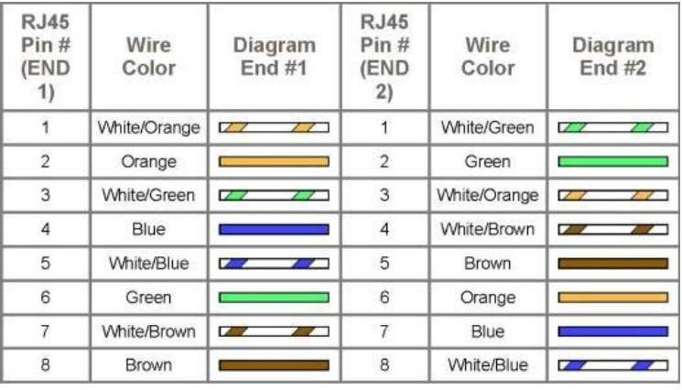
Diagram shows you how to prepare straight through wired connection
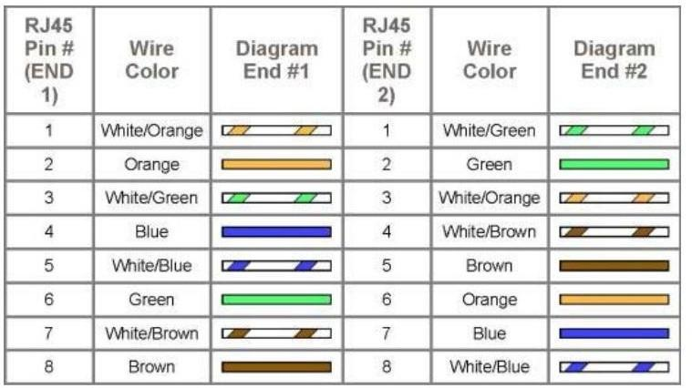

Experiment – 1
Aim: Study of following Network Devices in Detail
  - Repeater
  - Hub
  - Switch
  - Bridge
  - Router
  - Gate Way

Apparatus (Software): No software or hardware needed.
Procedure:: Following should be done to understand this practical.
- Repeater:Functioning at Physical Layer.Arepeater is an electronic device that receives a signal and retransmits it at a higher level and/or higher power, or onto the other side of an obstruction, so that the signal can cover longer distances. Repeater have two ports ,so cannot be use to connect for more than two devices

Hub: An Ethernet hub, active hub, network hub, repeater hub, hub or concentrator
is a device for connecting multiple twisted pair or fiber optic Ethernet devices together and making them act as a single network segment. Hubs work at the physical layer (layer 1) of the OSI model. The device is a form of multiport repeater. Repeater hubs also participate in collision detection, forwarding a jam signal to all ports if it detects a collision.

- Switch:Anetwork switch or switching hub is a computer networking device that connects network segments.The term commonly refers to a network bridge that processes and routes data at the data link layer (layer 2) of the OSI model. Switches that additionally process data at the network layer (layer 3 and above) are often referred to as Layer 3 switches or multilayer switches.
- Bridge: A network bridge connects multiple network segments at the data link layer (Layer 2) of the OSI model. In Ethernet networks, the term bridge formally means a device that behaves according to the IEEE 802.1D standard. A bridge and switch are very much alike; a switch being a bridge with numerous ports. Switch or Layer 2 switch is often used interchangeably with bridge .Bridges can analyze incoming data packets to determine if the bridge is able to send the given packet to another segment of the network.
- Router: A router is an electronic device that interconnects two or more computer networks, and selectively interchanges packets of data between them. Each data packet contains address information that a router can use to determine if the source and destination are on the same network, or if the data packet must be transferred from one network to another. Where multiple routers are used in a large collection of interconnected networks, the routers exchange information about target system addresses, so that each router can build up a table showing the preferred paths between any two systems on the interconnected networks.

- Gate Way: In a communications network, a network node equipped for interfacing with
another network that uses different protocols.
  - A gateway may contain devices such as protocol translators, impedance matching devices, rate converters, fault isolators, or signal translators as necessary to provide system interoperability. It also requires the establishment of mutually acceptable administrative Procedure:s between both networks.
  - A protocol translation/mapping gateway interconnects networks with different network protocol technologies by performing the required protocol conversions.

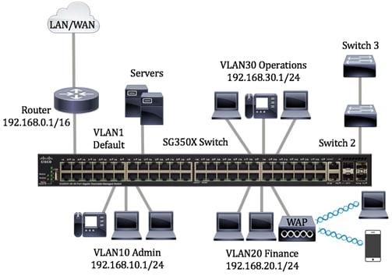

Figure .1 SG350X switch that is configured with the following VLANs

Viva Questions

1. What is Wireless LAN (WLAN)?
Answer:
Wireless LAN is a type of network that connects devices without using cables, using radio waves instead.

2. What devices are required to set up a Wireless LAN?
Answer:
Wireless router or access point, wireless network adapter, and end devices like laptops or mobiles.

3. What are the advantages of Wireless LAN over Wired LAN?
Answer:
Easy installation, mobility, flexibility, and reduced cabling cost.

4. Name the different types of network cables.
Answer:
Coaxial cable, Twisted Pair cable, and Fiber Optic cable.

5. What is Twisted Pair cable? Mention its types.
Answer:
Twisted Pair cable consists of twisted copper wires to reduce interference.
Types: UTP (Unshielded Twisted Pair) and STP (Shielded Twisted Pair).

6. What is Fiber Optic cable and where is it used?
Answer:
Fiber Optic cable transmits data using light signals. It is used for high-speed and long-distance communication.

7. What is a Cisco Router? What is its main function?
Answer:
A Cisco Router is a networking device that connects different networks and routes data packets between them.

8. Name the different ports available on a Cisco Router.
Answer:
Ethernet ports, Serial ports, Console port, and Auxiliary (AUX) port.

9. What is a Cisco Switch? How is it different from a hub?
Answer:
A Cisco Switch connects devices in a LAN and sends data only to the destination device, while a hub broadcasts data to all devices.

10. What are the types of Cisco Switches?
Answer:
Managed switches, Unmanaged switches, Layer 2 switches, and Layer 3 switches.

Experiment-2

Building a Local Area Network (LAN) using a Switch in Cisco Packet Tracer

AIM
To design and simulate a Local Area Network (LAN) using a switch in Cisco Packet Tracer, configure IP addressing in the 192.168.1.0/24 network, and verify connectivity between all PCs using ping and traceroute (tracert) commands.

Components Required
S.No | Component | Quantity
1 | Computer (PC) | 4
2 | Switch (2960) | 1
3 | Copper Straight-Through Cable | 4
4 | Cisco Packet Tracer Software | 1

Network Diagram (Logical Topology)
- Four PCs connected to a single switch
- Star topology
- All devices in the same network (192.168.1.0/24)

IP Addressing Scheme
Device | IP Address | Subnet Mask | Default Gateway
PC0 | 192.168.1.1 | 255.255.255.0 | —
PC1 | 192.168.1.2 | 255.255.255.0 | —
PC2 | 192.168.1.3 | 255.255.255.0 | —
PC3 | 192.168.1.4 | 255.255.255.0 | —
Note: Default Gateway is not required because no router is used.

PROCEDURE:

Step 1: Create the Network Topology
- Open Cisco Packet Tracer
- Drag and drop:
  - 1 Switch (2960)
  - 4 PCs
- Connect each PC to the switch using Copper Straight-Through cables:
  - PC → Fast Ethernet port
  - Switch → Fast Ethernet ports (Fa0/1 to Fa0/4)

Step 2: Configure IP Addressing on PCs
For each PC:
- Click on the PC
- Go to Desktop → IP Configuration
- Select Static
- Assign IP address and subnet mask as per the table above
Repeat for all four PCs.

Step 3: Verify Connectivity using Ping
- Click on PC0
- Go to Desktop → Command Prompt
- Type the following commands:
ping 192.168.1.2
ping 192.168.1.3
ping 192.168.1.4
- Successful replies confirm connectivity.
Repeat ping tests from other PCs if required.

Step 4: Verify Path using Traceroute
- From PC0 → Command Prompt
- Type:
tracert 192.168.1.4
- Output will show a single hop, indicating direct communication through the switch.

RESULT
- All four PCs were successfully connected using a switch.
- IP addresses were correctly configured in the 192.168.1.0/24 network.
- Ping was successful between all PCs.
- Traceroute (tracert) confirmed direct LAN connectivity.

CONCLUSION
A Local Area Network was successfully designed and implemented using Cisco Packet Tracer. Communication between all devices in the same network was verified using ping and traceroute commands.

Viva Questions

1. What is a Local Area Network (LAN)?
Answer:
A LAN is a network that connects computers within a limited area like a room or building.

2. What device is used to connect multiple PCs in a LAN?
Answer:
A switch is used to connect multiple PCs in a LAN.

3. Which switch is commonly used in Cisco Packet Tracer?
Answer:
Cisco 2960 switch.

4. Which cable is used to connect PC to switch?
Answer:
Copper Straight-Through cable.

5. Why is an IP address required in a LAN?
Answer:
An IP address uniquely identifies each device in the network.

6. What command is used to test network connectivity?
Answer:
The ping command.

7. What happens if ping is successful?
Answer:
It shows that devices are properly connected and can communicate.

8. On which OSI layer does a switch work?
Answer:
Data Link Layer (Layer 2).

9. What is the function of a switch?
Answer:
A switch forwards data only to the destination device using MAC addresses.

10. Can a switch connect different networks?
Answer:
No, a switch connects devices within the same network.

Experiment-3
Below is a clean, exam-ready Lab Manual prepared exactly as per the given diagram for Assigning & Verifying IP Address to Router using Cisco Packet Tracer.

Assigning and Verifying IP Address to Routers using Cisco Packet Tracer
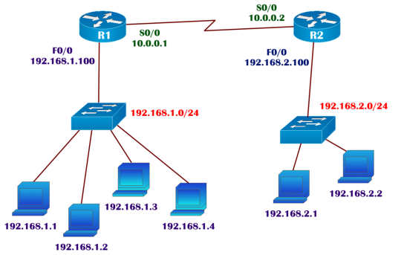

AIM
To design the given network topology in Cisco Packet Tracer, configure IP addresses on router interfaces according to the provided diagram and rules, and verify the interface status using router commands.

Components Required
S.No | Component | Quantity
1 | Router (R1, R2) | 2
2 | Switch | 2
3 | PCs | 6
4 | Copper Straight-Through Cables | As required
5 | Serial DCE Cable | 1
6 | Cisco Packet Tracer Software | 1

Network Topology Description
- Two routers (R1 and R2) connected using Serial interface
- Each router is connected to a LAN through a switch
- Left LAN uses 192.168.1.0/24
- Right LAN uses 192.168.2.0/24
- Serial link network uses 10.0.0.0

IP Addressing Table (As per Diagram)

Router Interfaces
Router | Interface | IP Address | Subnet Mask
R1 | FastEthernet0/0 | 192.168.1.100 | 255.255.255.0
R1 | Serial0/0 | 10.0.0.1 | 255.255.255.252
R2 | FastEthernet0/0 | 192.168.2.100 | 255.255.255.0
R2 | Serial0/0 | 10.0.0.2 | 255.255.255.252

PC IP Addresses
LAN-1 (192.168.1.0/24)
- PC0 → 192.168.1.1
- PC1 → 192.168.1.2
- PC2 → 192.168.1.3
- PC3 → 192.168.1.4
Gateway: 192.168.1.100
LAN-2 (192.168.2.0/24)
- PC4 → 192.168.2.1
- PC5 → 192.168.2.2
Gateway: 192.168.2.100

Procedure:

Step 1: Design the Topology
- Open Cisco Packet Tracer
- Place:
  - 2 Routers (R1, R2)
  - 2 Switches
  - 6 PCs
- Connect:
  - PCs to Switch using Copper Straight-Through
  - Switch to Router using Copper Straight-Through
  - Router to Router using Serial DCE cable

Step 2: Configure IP Address on Router R1
R1> enable
R1# configure terminal
R1(config)# interface fastEthernet 0/0
R1(config-if)# ip address 192.168.1.100 255.255.255.0
R1(config-if)# no shutdown
R1(config-if)# exit

R1(config)# interface serial 0/0
R1(config-if)# ip address 10.0.0.1 255.255.255.252
R1(config-if)# clock rate 64000
R1(config-if)# no shutdown
R1(config-if)# exit

Step 3: Configure IP Address on Router R2
R2> enable
R2# configure terminal
R2(config)# interface fastEthernet 0/0
R2(config-if)# ip address 192.168.2.100 255.255.255.0
R2(config-if)# no shutdown
R2(config-if)# exit

R2(config)# interface serial 0/0
R2(config-if)# ip address 10.0.0.2 255.255.255.252
R2(config-if)# no shutdown
R2(config-if)# exit

Step 4: Configure IP Address on PCs
For each PC:
- Click PC → Desktop → IP Configuration
- Assign IP address, subnet mask, and default gateway as per the table

Step 5: Verify Interface Status
On both routers, use:
show ip interface brief
✔ Confirms:
- IP address assignment
- Interface status (up/up)

Step 6: Connectivity Test
From any PC:
ping 192.168.1.100
ping 10.0.0.2
ping 192.168.2.1
Successful replies confirm correct configuration.

RESULT
- Network topology was successfully designed as per the given diagram.
- IP addresses were correctly assigned to router interfaces.
- Interface status was verified using router commands.
- Network connectivity was successfully established.

CONCLUSION
The experiment successfully demonstrated assigning and verifying IP addresses on router interfaces using Cisco Packet Tracer. Interface status and connectivity were confirmed using standard verification commands.

Viva Questions

1. What is the purpose of assigning an IP address to a router?
Answer:
To identify the router on a network and enable communication between devices.

2. Which command is used to enter privileged mode?
Answer:
enable

3. Which command is used to assign an IP address to an interface?
Answer:
ip address

4. Why is the no shutdown command used?
Answer:
To activate the router interface.

5. What is the default gateway in this experiment?
Answer:
The IP address of the router interface (192.168.1.1).

6. Which cable is used to connect PC and router?
Answer:
Copper Straight-Through cable.

7. What command is used to test connectivity?
Answer:
ping

8. What happens if the ping fails?
Answer:
It indicates an IP addressing or connectivity issue.

9. On which layer of the OSI model does a router work?
Answer:
Network Layer (Layer 3).

10. What is the function of a subnet mask?
Answer:
It separates the network and host portions of an IP address.

Experiment-4

Title
Configuring Static Routing using Cisco Packet Tracer

AIM
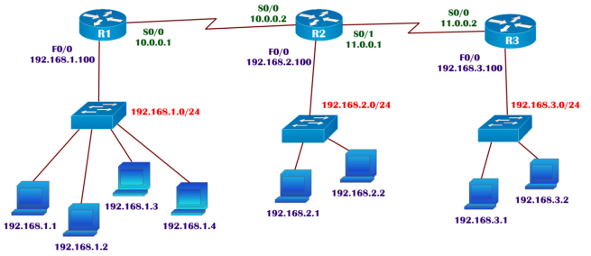
To design the given network topology in Cisco Packet Tracer, assign IP addresses as per the diagram, ensure all router interfaces are in UP/UP state, configure static routing, and verify routing tables and connectivity between LANs using PING and TRACEROUTE commands.

Components Required
S.No | Component | Quantity
1 | Routers (R1, R2, R3) | 3
2 | Switches | 3
3 | PCs | 8
4 | Copper Straight-Through Cables | As required
5 | Serial DCE Cables | 2
6 | Cisco Packet Tracer Software | 1

Network Topology Description
- Three routers connected in series (R1–R2–R3)
- Each router connects to one LAN via a switch
- Static routing is used for inter-LAN communication

IP Addressing Scheme (As per Diagram)

Router Interfaces
Router | Interface | IP Address | Subnet Mask
R1 | F0/0 | 192.168.1.100 | 255.255.255.0
R1 | S0/0 | 10.0.0.1 | 255.255.255.252
R2 | S0/0 | 10.0.0.2 | 255.255.255.252
R2 | F0/0 | 192.168.2.100 | 255.255.255.0
R2 | S0/1 | 11.0.0.1 | 255.255.255.252
R3 | S0/0 | 11.0.0.2 | 255.255.255.252
R3 | F0/0 | 192.168.3.100 | 255.255.255.0

PC IP Addresses
LAN-1 (192.168.1.0/24)
PCs: 192.168.1.1 – 192.168.1.4
Gateway: 192.168.1.100
LAN-2 (192.168.2.0/24)
PCs: 192.168.2.1, 192.168.2.2
Gateway: 192.168.2.100
LAN-3 (192.168.3.0/24)
PCs: 192.168.3.1, 192.168.3.2
Gateway: 192.168.3.100

PROCEDURE:

a) Design the Topology
- Open Cisco Packet Tracer
- Place:
  - 3 Routers (R1, R2, R3)
  - 3 Switches
  - 8 PCs
- Connect:
  - PCs → Switch (Copper Straight-Through)
  - Switch → Router (Copper Straight-Through)
  - Router ↔ Router (Serial DCE cable)

b) Assign IP Address According to Diagram

Router R1 Configuration
R1> enable
R1# configure terminal
R1(config)# interface f0/0
R1(config-if)# ip address 192.168.1.100 255.255.255.0
R1(config-if)# no shutdown
R1(config-if)# exit

R1(config)# interface s0/0
R1(config-if)# ip address 10.0.0.1 255.255.255.252
R1(config-if)# clock rate 64000
R1(config-if)# no shutdown
R1(config-if)# exit

Router R2 Configuration
R2> enable
R2# configure terminal
R2(config)# interface s0/0
R2(config-if)# ip address 10.0.0.2 255.255.255.252
R2(config-if)# no shutdown
R2(config-if)# exit

R2(config)# interface f0/0
R2(config-if)# ip address 192.168.2.100 255.255.255.0
R2(config-if)# no shutdown
R2(config-if)# exit

R2(config)# interface s0/1
R2(config-if)# ip address 11.0.0.1 255.255.255.252
R2(config-if)# clock rate 64000
R2(config-if)# no shutdown
R2(config-if)# exit

Router R3 Configuration
R3> enable
R3# configure terminal
R3(config)# interface s0/0
R3(config-if)# ip address 11.0.0.2 255.255.255.252
R3(config-if)# no shutdown
R3(config-if)# exit

R3(config)# interface f0/0
R3(config-if)# ip address 192.168.3.100 255.255.255.0
R3(config-if)# no shutdown
R3(config-if)# exit

c) Verify Interface Status (UP/UP)
On each router:
show ip interface brief
✔ All used interfaces should show up/up

d) Configure Static Routing

Static Routes on R1
R1(config)# ip route 192.168.2.0 255.255.255.0 10.0.0.2
R1(config)# ip route 192.168.3.0 255.255.255.0 10.0.0.2

Static Routes on R2
R2(config)# ip route 192.168.1.0 255.255.255.0 10.0.0.1
R2(config)# ip route 192.168.3.0 255.255.255.0 11.0.0.2

Static Routes on R3
R3(config)# ip route 192.168.1.0 255.255.255.0 11.0.0.1
R3(config)# ip route 192.168.2.0 255.255.255.0 11.0.0.1

e) Verify Routing Table & Reachability

Routing Table Verification
show ip route
✔ Static routes marked with S

Connectivity Test (PING)
From PC in LAN-1:
ping 192.168.2.1
ping 192.168.3.1

Path Verification (TRACERT)
tracert 192.168.3.1
✔ Shows path via R1 → R2 → R3

RESULT
- Network topology was successfully designed.
- IP addresses were correctly assigned.
- All router interfaces were in UP/UP state.
- Static routing was configured successfully.
- Connectivity between all LANs was verified using PING and TRACERT.

CONCLUSION
Static routing was successfully implemented in Cisco Packet Tracer, enabling communication between multiple LANs through intermediate routers. Routing tables and connectivity were verified using standard commands.

1. What is static routing?
Answer:
Static routing is a routing method where routes are manually configured by the network administrator.

2. Which command is used to configure static routing in a router?
Answer:
ip route

3. What are the components of the static route command?
Answer:
Destination network, subnet mask, and next-hop IP address (or exit interface).

4. Why is static routing used?
Answer:
It is used for small networks because it is simple, secure, and requires less bandwidth.

5. What is the next-hop IP address?
Answer:
It is the IP address of the next router where the packet should be forwarded.

6. On which OSI layer does static routing operate?
Answer:
Network Layer (Layer 3).

7. How can you verify static routes on a router?
Answer:
Using the command show ip route.

8. What is a default static route?
Answer:
A route that is used when no specific route is found for a destination network.

9. Write the command for configuring a default static route.
Answer:
ip route 0.0.0.0 0.0.0.0 <next-hop IP>

10. What is one disadvantage of static routing?
Answer:
Routes must be updated manually when the network changes.

Experiment-5

Configuring Default Route and Static Route using Cisco Packet Tracer

AIM
To design the given network topology in Cisco Packet Tracer, assign IP addresses according to the diagram, ensure all interfaces are in UP–UP state, configure default routing on R1 and R3 and static routing on R2, and verify routing tables and connectivity between LANs using PING and TRACEROUTE commands.

Components Required
S.No | Component | Quantity
1 | Routers (R1, R2, R3) | 3
2 | Switches | 3
3 | PCs | 8
4 | Copper Straight-Through Cables | As required
5 | Serial DCE Cables | 2
6 | Cisco Packet Tracer | 1

Network Topology Description
- Three routers connected linearly: R1 – R2 – R3
- Each router connects to one LAN
- R1 and R3 use default routes
- R2 uses static routes

IP Addressing Scheme (As per Diagram)

Router Interfaces
Router | Interface | IP Address | Subnet Mask
R1 | F0/0 | 192.168.1.100 | 255.255.255.0
R1 | S0/0 | 10.0.0.1 | 255.255.255.252
R2 | S0/0 | 10.0.0.2 | 255.255.255.252
R2 | F0/0 | 192.168.2.100 | 255.255.255.0
R2 | S0/1 | 11.0.0.1 | 255.255.255.252
R3 | S0/0 | 11.0.0.2 | 255.255.255.252
R3 | F0/0 | 192.168.3.100 | 255.255.255.0

PC IP Configuration
LAN 1 – 192.168.1.0/24
PCs: 192.168.1.1 – 192.168.1.4
Gateway: 192.168.1.100
LAN 2 – 192.168.2.0/24
PCs: 192.168.2.1, 192.168.2.2
Gateway: 192.168.2.100
LAN 3 – 192.168.3.0/24
PCs: 192.168.3.1, 192.168.3.2
Gateway: 192.168.3.100

PROCEDURE:

a) Design the Topology
- Open Cisco Packet Tracer
- Place:
  - 3 Routers (R1, R2, R3)
  - 3 Switches
  - 8 PCs
- Connect:
  - PC → Switch (Copper Straight-Through)
  - Switch → Router (Copper Straight-Through)
  - Router ↔ Router (Serial DCE cable)

b) Assign IP Address According to Diagram

Router R1
enable
configure terminal
interface f0/0
ip address 192.168.1.100 255.255.255.0
no shutdown
exit

interface s0/0
ip address 10.0.0.1 255.255.255.252
clock rate 64000
no shutdown
exit

Router R2
enable
configure terminal
interface s0/0
ip address 10.0.0.2 255.255.255.252
no shutdown
exit

interface f0/0
ip address 192.168.2.100 255.255.255.0
no shutdown
exit

interface s0/1
ip address 11.0.0.1 255.255.255.252
clock rate 64000
no shutdown
exit

Router R3
enable
configure terminal
interface s0/0
ip address 11.0.0.2 255.255.255.252
no shutdown
exit

interface f0/0
ip address 192.168.3.100 255.255.255.0
no shutdown
exit

c) Verify Interfaces are in UP–UP State
On each router:
show ip interface brief
✔ All used interfaces should display up/up

d) Configure Routing

Default Route on R1
ip route 0.0.0.0 0.0.0.0 10.0.0.2

Static Routes on R2
ip route 192.168.1.0 255.255.255.0 10.0.0.1
ip route 192.168.3.0 255.255.255.0 11.0.0.2

Default Route on R3
ip route 0.0.0.0 0.0.0.0 11.0.0.1

e) Verify Routing Table & Reachability

Routing Table Verification
show ip route
- Default route shown as S*
- Static routes shown as S

PING Test
From a PC in LAN 1:
ping 192.168.2.1
ping 192.168.3.1

TRACEROUTE Test
tracert 192.168.3.1
✔ Path: R1 → R2 → R3

RESULT
- Topology was designed successfully.
- IP addresses were assigned correctly.
- All interfaces were in UP–UP state.
- Default routing and static routing were configured successfully.
- Connectivity between all LANs was verified using PING and TRACEROUTE.

CONCLUSION
Default routing on edge routers (R1 and R3) and static routing on the core router (R2) enabled successful communication between multiple LANs in Cisco Packet Tracer.

Viva Questions:

1. What is static routing?
Answer:
Static routing is a method where routes are manually configured by the network administrator.

2. What is a default route?
Answer:
A default route is used when no specific route is available for the destination network.

3. Which command is used to configure static and default routes?
Answer:
The ip route command.

4. What is the purpose of a default route?
Answer:
To forward packets to unknown networks through a single route.

5. What is meant by next-hop IP address?
Answer:
It is the IP address of the next router to which data packets are forwarded.

6. On which OSI layer does routing operate?
Answer:
Network Layer (Layer 3).

7. Write the command syntax for a static route.
Answer:
ip route <destination network> <subnet mask> <next-hop IP>

8. Write the command for configuring a default route.
Answer:
ip route 0.0.0.0 0.0.0.0 <next-hop IP>

9. How can you verify configured routes on a router?
Answer:
By using the command show ip route.

10. Mention one difference between static route and default route.
Answer:
A static route is configured for a specific network, while a default route is used for all unknown networks.

Experiment-6

Title
Write a program to demonstrate Connectionless UDP Protocol
- Write a Program to demonstrate connectionless(UDP) Echo Service Using Well Known / Standard Port

Aim
To write a Program to demonstrate connectionless(UDP) Echo Service Using Well Known / Standard Port

Software / Tools Required
- Dev C++
- PC / Laptop

Network Topology
- Routers: R1, R2, R3
- Switches: One switch per LAN
- End Devices: PCs in each LAN
- Routing Protocol: EIGRP (Autonomous System 100)
Topology consists of three routers connected serially, each router connected to its own LAN.

IP Addressing Scheme

Router Interfaces
R1
- FastEthernet0/0 : 192.168.1.100 /24
- Serial0/0 : 10.0.0.1 /30
R2
- FastEthernet0/0 : 192.168.2.100 /24
- Serial0/0 : 10.0.0.2 /30
- Serial0/1 : 11.0.0.1 /30
R3
- FastEthernet0/0 : 192.168.3.100 /24
- Serial0/0 : 11.0.0.2 /30

PC IP Addresses
LAN 1 (192.168.1.0/24)
- PC1: 192.168.1.1
- PC2: 192.168.1.2
- PC3: 192.168.1.3
- PC4: 192.168.1.4
- Gateway: 192.168.1.100
LAN 2 (192.168.2.0/24)
- PC1: 192.168.2.1
- PC2: 192.168.2.2
- Gateway: 192.168.2.100
LAN 3 (192.168.3.0/24)
- PC1: 192.168.3.1
- PC2: 192.168.3.2
- Gateway: 192.168.3.100

Procedure:

Step 1: Design the Topology
- Open Cisco Packet Tracer
- Place three routers (R1, R2, R3)
- Connect routers using Serial DCE/DTE cables
- Connect switches and PCs using Copper Straight-Through cables

Program:
#include<stdio.h>
#include<stdlib.h>
#include<sys/socket.h>
#include<netinet/in.h>
#include<sys/types.h>
#include<string.h>
main(int argc,char* argv[])
{
struct sockaddr_in s;
int rval,sockid,slen;
char m1[20],m2[20];
system("clear");
if(argc<3)
{
printf("\nUSAGE : %s IP-Address Port#\n",argv[0]);
exit(1);
}
sockid=socket(AF_INET,SOCK_DGRAM,0);
if(sockid==-1)
{
perror("SOCK-CRE-ERR:");
exit(1);
}
s.sin_family=AF_INET;
s.sin_addr.s_addr=inet_addr(argv[1]);
s.sin_port=htons(atoi(argv[2]));
printf("\nEnter the request message : ");
scanf("%s",m1);
slen=sizeof(s);
rval=sendto(sockid,m1,sizeof(m1),0,(struct sockaddr*)&s,slen);
if(rval==-1)
{
perror("MSG-SEND-ERR:");
exit(1);
}
printf("\nMessage sent successfully\n");
strncpy(m2," ",20);
rval=recvfrom(sockid,m2,sizeof(m2),0,(struct sockaddr*)&s,&slen);
if(rval==-1)
{
perror("MSG-RCV-ERR:");
exit(1);
}
printf("\nMessage received is : %s\n",m2);
close(sockid);

Step 3: Ensure Interfaces are UP/UP
Use the following command on each router:
show ip interface brief
All interfaces should show up/up status.

Step 4: Configure EIGRP Dynamic Routing (AS 100)

R1 EIGRP Configuration
router eigrp 100
network 192.168.1.0 0.0.0.255
network 10.0.0.0 0.0.0.3
no auto-summary

R2 EIGRP Configuration
router eigrp 100
network 192.168.2.0 0.0.0.255
network 10.0.0.0 0.0.0.3
network 11.0.0.0 0.0.0.3
no auto-summary

R3 EIGRP Configuration
router eigrp 100
network 192.168.3.0 0.0.0.255
network 11.0.0.0 0.0.0.3
no auto-summary

Verification
OUTPUT:
/* cc is used for compiling the program */
compilation : cc udp_client.c
/* Then execute the client program. a.out is the default compiled executable file. To view its contents we use ./a.out */
execution : ./a.out 10.2.0.3 7 (7 is the port for standard echo service)
CLIENT
Put your output screen shot here

Result
OUTPUT:
/* cc is used for compiling the program */
compilation : cc udp_client.c
/* Then execute the client program. a.out is the default compiled executable file. To view its contents we use ./a.out */
execution : ./a.out 10.2.0.3 7 (7 is the port for standard echo service)
CLIENT

Conclusion
EIGRP enables efficient and fast dynamic routing between multiple networks. This lab demonstrates successful design, configuration, and verification of EIGRP routing in a multi-router environment using Cisco Packet Tracer.

1. What is EIGRP?
Answer:
EIGRP (Enhanced Interior Gateway Routing Protocol) is a Cisco proprietary dynamic routing protocol.

2. Is EIGRP a distance vector or link-state protocol?
Answer:
EIGRP is an advanced distance vector (hybrid) routing protocol.

3. What is the Autonomous System (AS) number in EIGRP?
Answer:
The AS number identifies the EIGRP routing domain; in this experiment it is AS 100.

4. Which command is used to enable EIGRP on a router?
Answer:
router eigrp 100

5. Which command is used to advertise networks in EIGRP?
Answer:
network <network address>

6. What metric does EIGRP use to select the best path?
Answer:
EIGRP uses bandwidth and delay as its primary metrics.

7. Which algorithm is used by EIGRP?
Answer:
DUAL (Diffusing Update Algorithm).

8. How does EIGRP send routing updates?
Answer:
EIGRP sends partial and triggered updates, not full periodic updates.

9. Which command is used to verify EIGRP routes?
Answer:
show ip route

10. Mention one advantage of EIGRP.
Answer:
Fast convergence and efficient use of bandwidth.

b. Write a Program to demonstrate connectionless(UDP) Date and Time Service Using Well Known / Standard Port
Program:
#include<stdio.h>
#include<stdlib.h>
#include<sys/socket.h>
#include<netinet/in.h>
#include<sys/types.h>
#include<string.h>
main(int argc,char* argv[])
{
struct sockaddr_in s;
int rval,sockid,slen;
char m1[20],m2[20];
system("clear");
if(argc<3)
{
printf("\nUSAGE : %s IP-Address Port#\n",argv[0]);
exit(1);
}
sockid=socket(AF_INET,SOCK_DGRAM,0);
if(sockid==-1)
{
perror("SOCK-CRE-ERR:");
exit(1);
}
s.sin_family=AF_INET;
s.sin_addr.s_addr=inet_addr(argv[1]);
s.sin_port=htons(atoi(argv[2]));

printf("\nEnter the request message : ");
scanf("%s",m1);
slen=sizeof(s);
rval=sendto(sockid,m1,sizeof(m1),0,(struct sockaddr*)&s,slen);
if(rval==-1)
{
perror("MSG-SEND-ERR:");
exit(1);
}
printf("\nMessage sent successfully\n");
strncpy(m2," ",20);
rval=recvfrom(sockid,m2,sizeof(m2),0,(struct sockaddr*)&s,&slen);
if(rval==-1)
{
perror("MSG-RCV-ERR:");
exit(1);
}
printf("\nMessage received is : %s\n",m2);
close(sockid);
}

OUTPUT:
compilation : cc udp_client.c
execution : ./a.out 10.2.0.3 13 (13 is the port for standard daytime service)
CLIENT
Put your output screen shot here

Experiment-7

Title
Write a program to demonstrate TCP connection-oriented Protocol

Aim
To study the role of a connection oriented protocol TCP

3a. Write a Program to Demonstrate Connection oriented (TCP) Echo Service Using Well Known / Standard Port
Program:
#include<stdio.h>
#include<stdlib.h>
#include<sys/types.h>
#include<sys/socket.h>
#include<netinet/in.h>
main(int argc,char* argv[])
{
struct sockaddr_in s;
int sockid,rval;
char m1[20],m2[20];
sockid=socket(AF_INET,SOCK_STREAM,0);
if(sockid==-1)
{
perror("SOCK-CRE-ERR");
exit(1);
}
system("clear");
if(argc<3)
{
printf("\nUSAGE : %s IP_ADDR PORT#\n",argv[0]);
exit(0);
}
s.sin_family=AF_INET;
s.sin_addr.s_addr=inet_addr(argv[1]);
s.sin_port=htons(atoi(argv[2]));

rval=connect(sockid,(struct sockaddr*)&s, sizeof(s));
if(rval==-1)
{
perror("CONN-ERR:");
close(sockid);
exit(1);
}
printf("\nEnter the request message : ");
scanf("%s",m1);
rval=send(sockid,m1,sizeof(m1),0);
if(rval==-1)
{
perror("MSG-SND-ERR:");
close(sockid);
exit(1);
}
printf("\nMessage sent successfully\n");
rval=recv(sockid,m2,sizeof(m2),0);
if(rval==-1)
{
perror("MSG-RCV-ERR:");
close(sockid);
exit(1);
}
printf("\nServer response is : %s\n",m2);
close(sockid);
}

OUTPUT:
compilation : cc tcp_client.c
execution : ./a.out 10.2.0.3 7 (7 is the port for standard echo service)
Client:
Put your output screen shot here
3b. Write a Program to Demonstrate Connection oriented (TCP) Date and Time Service Using Well Known / Standard Port
Program:
#include<stdio.h>
#include<stdlib.h>
#include<sys/types.h>
#include<sys/socket.h>
#include<netinet/in.h>

main(int argc,char* argv[])
{
struct sockaddr_in s;
int sockid,rval;
char m[20];
sockid=socket(AF_INET,SOCK_STREAM,0);
if(sockid==-1)
{
perror("SOCK-CRE-ERR");
exit(1);
}

system("clear");
if(argc<3)
{
printf("\nUSAGE : %s IP_ADDR PORT#\n",argv[0]);
exit(0);
}
s.sin_family=AF_INET;
s.sin_addr.s_addr=inet_addr(argv[1]);
s.sin_port=htons(atoi(argv[2]));
rval=connect(sockid,(struct sockaddr*)&s, sizeof(s));
if(rval==-1)
{
perror("CONN-ERR:");
close(sockid);
exit(1);
}
rval=recv(sockid,m,sizeof(m),0);
if(rval==-1)
{
perror("MSG-RCV-ERR:");
close(sockid);
exit(1);
}
printf("\nServer response is : %s\n",m);
close(sockid);
}

OUTPUT:
compilation : cc tcp_client.c
execution : ./a.out 10.2.0.3 13 (13 is the port for standard daytime service)

CLIENT
Put your output screen shot here
3c. Write a Program to Demonstrate Connection oriented (TCP) Character generation Service Using
Well Known / Standard Port
Program:
#include<stdio.h>
#include<stdlib.h>
#include<sys/types.h>
#include<sys/socket.h>
#include<netinet/in.h>
main(int argc,char* argv[])
{
struct sockaddr_in s;
int sockid,rval;
char m1[20],m2[50];
sockid=socket(AF_INET,SOCK_STREAM,0);
if(sockid==-1)
{
perror("SOCK-CRE-ERR");
exit(1);
}

system("clear");
if(argc<3)
{
printf("\nUSAGE : %s IP_ADDR PORT#\n",argv[0]);
exit(0);
}
s.sin_family=AF_INET;
s.sin_addr.s_addr=inet_addr(argv[1]);
s.sin_port=htons(atoi(argv[2]));

rval=connect(sockid,(struct sockaddr*)&s, sizeof(s));
if(rval==-1)
{
perror("CONN-ERR:");
close(sockid);
exit(1);
}
printf("\nEnter the request message : ");
scanf("%s",m1);
rval=send(sockid,m1,sizeof(m1),0);
if(rval==-1)
{
perror("MSG-SND-ERR:");
close(sockid);
exit(1);
}
printf("\nMessage sent successfully\n");
rval=recv(sockid,m2,sizeof(m2),0);
if(rval==-1)
{
perror("MSG-RCV-ERR:");
close(sockid);
exit(1);
}
printf("\nServer response is : %s\n",m2);
close(sockid);
}

OUTPUT:
compilation : cc tcp_client.c
execution : ./a.out 10.2.0.3 19 (19 is the port for standard char-gen service)

CLIENT
Put your output screen shot here
3d. Write a Program to demonstrate connection-oriented time service using well known port.
Program:
#include<stdio.h>
#include<stdlib.h>
#include<sys/types.h>
#include<sys/socket.h>
#include<netinet/in.h>
main(int argc,char* argv[])
{
unsigned long timeval,tempval;
int sockid,rval;
char m1[20],m2[20];
sockid=socket(AF_INET,SOCK_STREAM,0);
if(sockid==-1)
{
perror("SOCK-CRE-ERR");
exit(1);
}
struct sockaddr_in s;
system("clear");
if(argc<3) {
printf("\nUSAGE : %s IP_ADDR PORT#\n",argv[0]);
exit(0); }
s.sin_family=AF_INET;
s.sin_port=htons(atoi(argv[2]));
s.sin_addr.s_addr=inet_addr(argv[1]);
rval=connect(sockid,(struct sockaddr*)&s, sizeof(s));
if(rval==-1)
{
perror("CONN-ERR:");
close(sockid);
exit(1);
}
printf("\nEnter the request message : ");
scanf("%s",m1);
rval=send(sockid,m1,sizeof(m1),0);
if(rval==-1)
{
perror("MSG-SND-ERR:");
close(sockid);
exit(1);
}
printf("\nMessage sent successfully\n");
rval=recv(sockid,&tempval,sizeof(tempval),0);
if(rval==-1) {
perror("MSG-RCV-ERR:");
close(sockid);
exit(1); }
timeval=htonl(tempval);
printf("\nServer response is : %u\n",timeval);
close(sockid);
}

OUTPUT:
compilation : cc tcp_client.c
execution : ./a.out 10.2.0.3 37 (37 is the port for time protocol service)
CLIENT
Put your output screen shot here

Experiment 8
Program 11
a) Write a program to implement echo service using RPC.
Program Definition
To implement Remote File Access using Remote Procedure Call.
Program Description
A file at the server is to be accessed using Remote Procedure calls.High-level programming through remote procedure calls (RPC) provides logical client-to-server communication for network application development - without the need to program most of the interface to the underlying network. With RPC, the client makes a remote procedure call that sends requests to the server, which calls a dispatch routine, performs the requested service, and sends back a reply before the returns to the client.
RPC does not require the caller to know about the underlying network (it looks similar to a call to a C routine).
RPC model - Figure below illustrates the basic form of network communication with the RPC (synchronous model).
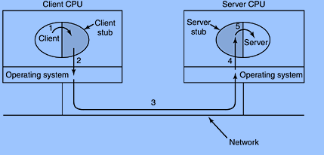
The local function call model works as follows:
- The caller places arguments to a procedure in a specific location(such as a result register).
- The caller temporarily transfers control to the procedure.
- When the caller gains control again, it obtains the results of the procedure from the specified location.
- The caller then continues program.
The RPC is similar, in that one thread of control logically winds through two processes – that of the caller and that of the server.
- The caller process sends a call message to the server process and blocks for a reply. The call message contains the parameters of the procedure and the reply message contains the procedure results.
- When the caller receives the reply message, it gets the results of the procedure.
- The caller process then continues executing.
On the server side a process is dormant – awaiting the arrival of a call message. When one arrives, the server process computes a reply that is then sent back to the client. After this the server again becomes dormant.
Writing RPC applications with the rpcgen protocol compiler - It accept a remote program interface definition written in RPC language (which is similar to C). It then produces C language output consisting Skeleton versions of the client routines, a server skeleton, XDR filter routines for both parameters and results, a header file that contains common definitions, and optionally dispatch tables that the server uses to invoke routines that are based on authorization checks.
The client skeleton interface to the RPC library hides the network from its callers, and the server skeleton hides the network from the server procedures invoked by remote clients.
Header file to include: <rpc/rpc.h>
The client handle is created in the client program that is generated by rpcgen compiler. The RPC is called through the client. This request passes over the network and reaches server side wherein server stub calls this procedure. The RPC returns the contents of file to the server stub and it travels through the network to the client stub and back to client where it is displayed.

Algorithm
STEPS:
- Create the Specification file, a file with .x extension.
- Compile it using rpcgen compiler which creates the stubs and the client and server programs
Client:
- Specify the RPC header client.
- Using this Create Client handle and invoke a protocol (UDP).
- Call the remote procedure using the handle.
- On return ,display the file contents
- Destroy the client handle
- Stop
Server:
- Declare the static variables for result.
- Open the file for which request came from client
- Read its contents into a buffer.
- Return the buffer as result

A remote procedure is uniquely identified by the triple:
(program number, version number, procedure number)
The program number identifies a group of related remote procedures, each of which has a unique procedure number.
A program may consist of one or more versions.
Each version consists of a collection of procedures which are available to be called remotely. Version numbers enable multiple versions of an RPC protocol to be available simultaneously. Each version contains a a number of procedures that can be called remotely. Each procedure has a procedure number.

//program name: echo.x
program ECHOPRG{
version ECHOER{
string echo(string)=1;
}=1;
}=0x20000001;

// compiling echo.x using rpcgen
$ rpcgen –a echo.x
$ ls
// seeing the list of files which gets created(6 files)
echo.h echo.x echo_client.c echo_clnt.c echo_server.c echo_svc.c Makefile.echo
// open echo_server.c to do changes.
//echo_server.c
/*
* This is sample code generated by rpcgen.
* These are only templates and you can use them
* as a guideline for developing your own functions.
*/

#include "echo.h"

char **
echo_1_svc(char **argp, struct svc_req *rqstp)
{
static char * result;

/*
* insert server code here
*/
result=*argp;
return &result;
}

// open echo_client.c to make changes
//echo_client.c
/*
* This is sample code generated by rpcgen.
* These are only templates and you can use them
* as a guideline for developing your own functions.
*/

#include "echo.h"

void
echoprg_1(char *host,char *str)//argument for ECHOPRG_1
{
CLIENT *clnt;
char * *result_1;
char * echo_1_arg;

#ifndef DEBUG
clnt = clnt_create (host, ECHOPRG, ECHOER, "udp");//used for creating client.can use udp or tcp
if (clnt == NULL) {
clnt_pcreateerror (host);
exit (1);
}
#endif /* DEBUG */
echo_1_arg=str;
result_1 = echo_1(&echo_1_arg, clnt);//for calling client stub
if (result_1 == (char **) NULL) {
clnt_perror (clnt, "call failed");
// printf("%s",*result_1);
}
else
printf("%s",*(result_1));
#ifndef DEBUG
clnt_destroy (clnt);
#endif /* DEBUG */
}
Int main (int argc, char *argv[])
{
char *host;

if (argc < 2) {
printf ("usage: %s server_host\n", argv[0]);
exit (1);
}
host = argv[1];
echoprg_1 (host,argv[2]);
exit (0);
}
OUTPUT:
//compiling server and server stub program
$ cc echo_server.c echo_svc.c –o recho
$ ./recho (In Server Terminal)
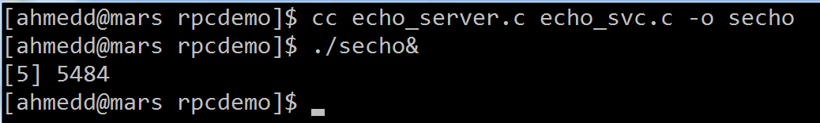

// compiling client and client stub program
$ cc echo_client.c echo_clnt.c

$ ./a.out 10.2.0.3 str (In Client Terminal)
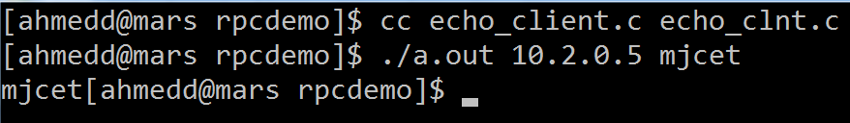

11 b)Write a program to implement date and time service using RPC.
program name:day.x

program DAYPRG{
version DAYVER{
string day(void)=1;
}=1;
}=0x20000001;
// compiling day.x using rpcgen
$ rpcgen –a day.x
$ ls
// seeing the list of files which gets created(6 files)
$ day.h day.x day_client.c day_clnt.c day_server.c day_svc.c Makefile.day
// open day_server.c to do changes.
//day_server.c
/*
* This is sample code generated by rpcgen.
* These are only templates and you can use them
* as a guideline for developing your own functions.
*/

#include "day.h"
#include "time.h"

char **
day_1_svc(void *argp, struct svc_req *rqstp)
{
static char * result;

/*
* insert server code here
*/
time_t t;
time(&t);
result=ctime(&t); //&t returns time and ctime gives the correct format of time

return &result;
}
// open day_client.c to make changes
//day_client.c
/*
* This is sample code generated by rpcgen.
* These are only templates and you can use them
* as a guideline for developing your own functions.
*/
#include "day.h"
void
dayprg_1(char *host)
{
CLIENT *clnt;
char * *result_1;
char *day_1_arg;

#ifndef DEBUG
clnt = clnt_create (host, DAYPRG, DAYVER, "udp");
if (clnt == NULL) {
clnt_pcreateerror (host);
exit (1);
}
#endif /* DEBUG */

result_1 = day_1((void*)&day_1_arg, clnt);
if (result_1 == (char **) NULL) {
clnt_perror (clnt, "call failed");
}
printf("%s",*result_1);
#ifndef DEBUG
clnt_destroy (clnt);
#endif /* DEBUG */
}
int
main (int argc, char *argv[])
{
char *host;

if (argc < 2)
{
printf ("usage: %s server_host\n", argv[0]);
exit (1);
}
host = argv[1];
dayprg_1 (host);
exit (0);
}
OUTPUT:
//compiling server and server stub program
$ cc day_server.c day_svc.c –o rday
$ ./rday (In Server Terminal)

$ cc day_client.c day_clnt.c
$ ./a.out 10.2.0.3 (In Client Terminal)

Experiment 9
9.Write a Program to Implement Mini DNS Service
Program:
/*CREATING DNSfile.txt*/
lab7 10.2.0.7
lab9 10.2.0.9
lab6 10.2.0.6
/*DNS CLIENT PROGRAM*/
#include<stdio.h>
#include<stdlib.h>
#include<sys/types.h>
#include<sys/socket.h>
#include<netinet/in.h>
#include<string.h>
main(int argc,char* argv[])
{
struct sockaddr_in dnss;
int sockid,rval;
char sym[20],IP[20];
int slen;
system("clear");
if(argc<3)
{
printf("\nUSAGE : %s IP_ADDR PORT#\n",argv[0]);
exit(1);
}
sockid=socket(AF_INET,SOCK_DGRAM,0);
if(sockid==-1)
{
perror("SOCK-CRE-ERR:");
exit(1);
}
dnss.sin_family=AF_INET;
dnss.sin_port=htons(atoi(argv[2]));
dnss.sin_addr.s_addr=inet_addr(argv[1]);

printf("\nEnter the symbolic name of resource : ");
scanf("%s",sym);
rval=sendto(sockid,sym,sizeof(sym),0,(struct sockaddr*)&dnss,sizeof(dnss));
if(rval==-1)
{
perror("MSG-SND-ERR:");
close(sockid);
exit(1);
}
printf("\nWaiting to receive from DNS Server\n");
slen=sizeof(dnss);
strncpy(IP," ",20);
rval=recvfrom(sockid,IP,sizeof(IP),0,(struct sockaddr*)&dnss,&slen);
if(rval==-1)
{
perror("MSG-RCV-ERR:");
close(sockid);
exit(1);
}
printf("\nEquivalent IP adrress of %s is %s\n",sym,IP);
close(sockid);
}
/*DNS SERVER PROGRAM*/
#include<stdio.h>
#include<stdlib.h>
#include<sys/types.h>
#include<sys/socket.h>
#include<netinet/in.h>
#include<string.h>
main(int argc,char* argv[])
{
struct sockaddr_in dnss,dnsc;
int rval,sockid,flag=0,clen;
char sym[20],IP[20],dnsFile[20],dnsName[20];
FILE *fptr;
system("clear");
if(argc<3)
{
printf("\nUSAGE : %s IP_ADDR PORT#\n",argv[0]);
exit(1);
}
dnss.sin_family=AF_INET;
dnss.sin_addr.s_addr=inet_addr(argv[1]);
dnss.sin_port=htons(atoi(argv[2]));
sockid=socket(AF_INET,SOCK_DGRAM,0);
if(sockid==-1)
{
perror("SOCK-CRE-ERR:");
exit(1);
}
rval=bind(sockid,(struct sockaddr*)&dnss,sizeof(dnss));
if(rval==-1)
{
perror("BIND-ERR:");
close(sockid);
exit(1);
}
printf("\nDNS Server waiting for request\n");
printf("\nEnter the DNS file name : ");
scanf("%s",dnsFile);
/*OPEN THE FILE*/
fptr=fopen(dnsFile,"r");
if(fptr==NULL)
{
perror("FILE-OPEN-ERR:");
close(sockid);
exit(1);
}
clen=sizeof(dnsc);
rval=recvfrom(sockid,sym,sizeof(sym),0,(struct sockaddr*)&dnsc,&clen);
if(rval==-1)
{
perror("MSG-RCV-ERR:");
close(sockid);
fclose(fptr);
exit(1);
}
printf("\nIP requested for %s\n",sym);
while((fscanf(fptr,"%s%s",dnsName,IP) != EOF) )
{
if(strcmp(dnsName,sym)==0)
{
rval=sendto(sockid,IP,sizeof(IP),0,(struct sockaddr*)&dnsc,clen);
if(rval==-1)
{
perror("MSG-SND-ERR:");
fclose(fptr);
close(sockid);
exit(1);
}
flag=1;
}
printf("\n flag value in loop is %d\n",flag);
if(flag==1) //INDICATES THAT MATCH IS FOUND
break;
}
if(flag==0)
{
printf("\n invalid domain name case\n");
rval=sendto(sockid,"NOT FOUND",sizeof("NOT FOUND"),0,(struct sockaddr*)&dnsc,clen);
if(rval==-1)
{
perror("MSG-SND-ERR:");
fclose(fptr);
close(sockid);
exit(1);
}
}
fclose(fptr);
close(sockid);
}
OUTPUT:
compilation : cc –o cout dnsClient.c
cc –o sout dnsServer.c
execution : ./sout 10.2.0.35080 (Execute server first and in terminal 1)
./cout 10.2.0.3 5080 (Execute client second and in terminal 2)
DNS File
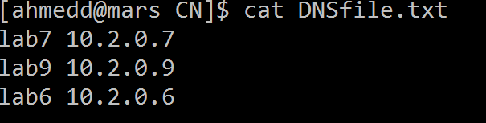
Server:
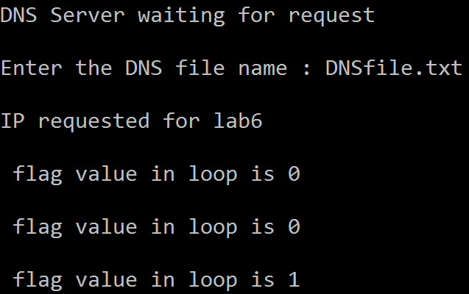

Client:
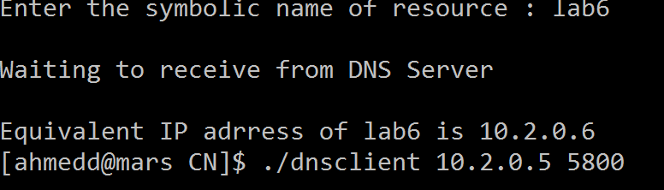

EXPERIMENT NO: 10

10 (a) NAME OF THE EXPERIMENT: Bit Stuffing.

OBJECTIVE: Implement the data link layer framing method.

RESOURCE: Turbo C

PROGRAM LOGIC:
The new technique allows data frames to contain an arbitrary number if bits and allows character codes with an arbitrary no of bits per character. Each frame begins and ends with special bit pattern, 01111110, called a flag byte. Whenever the sender’s data link layer encounters five consecutive ones in the data, it automatically stuffs a 0 bit into the outgoing bit stream. This bit stuffing is analogous to character stuffing, in which a D LE is stuffed into the outgoing character stream before DLE in the data.

SOURCE CODE:
// BIT Stuffing program #include<stdio.h> #include<conio.h> #include<string.h>
void main()
{
int a[20],b[30],i,j,k,count,n; clrscr();
printf("Enter frame length:"); scanf("%d",&n);
printf("Enter input frame (0's & 1's only):"); for(i=0;i<n;i++)
scanf("%d",&a[i]); i=0;
count=1; j=0;
while(i<n)
{
if(a[i]==1)
{
b[j]=a[i];
for(k=i+1;a[k]==1 && k<n &&count<5;k++)
{
j++;
b[j]=a[k]; count++;

if
(count = = 5 )

{
j++; b[j]=0;
}

i=k;
}
}
else
{
b[j]=a[i];
} i++; j++;
}
printf("After stuffing the frame is:"); for(i=0;i<j;i++)
printf("%d",b[i]); getch();
}

OUTPUT:
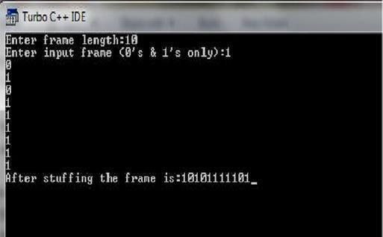

Viva questions:

- What is Stuffing?
- What is use of Stuffing?
- With bit stuffing the boundary between two frames can be unambiquously recognize by?
- ------ is a analogous to character stuffing.
- The senders data link layer encounters no of 1’s consecutively

10 (b): NAME OF THE EXPERIMENT: Character Stuffing.

OBJECTIVE: Implement the data link layer framing methods. RESOURCE: Turbo C

PROGRAM LOGIC:
The framing method gets around the problem of resynchronization after an error by ha vi ng each frame start with the ASCII character sequence DLE STX and the sequence DLE ETX. If the destination ever losses the track of the frame boundaries all it has to do is look for DLE STX or DLE ETX characters to figure out. The data link layer on the receiving end removes the DLE before the data are given to the network layer. This technique is called character stuffing.

PROCEDURE: Go to debug -> run or press CTRL + F9 to run the program.

SOURCE CODE:
//PROGRAM FOR CHARACTER STUFFING
#include<stdio.h> #include<conio.h> #include<string.h> #include<process.h> void main()
{
int i=0,j=0,n,pos;
char a[20], b[50], ch;
clrscr();
printf("enter string\n"); scanf("%s",&a); n=strlen(a);
printf("enter position\n"); scanf("%d",&pos); if(pos>n)
{
printf("invalid position, Enter again :"); scanf("%d",&pos);
}
printf("enter the character\n"); ch=getche();
b[0]='d';
b[1]='l';
b[2]='e';
b[3]='s';
b[4]='t';
b[5]='x'; j=6;
while(i<n)
{

if(i==pos-1)
{
b[j]='d';
b[j+1]='l';
b[j+2]='e';
b[j+3]=ch; b[j+4]='d';
b[j+5]='l';
b[j+6]='e';
j=j+7;
}
if(a[i]=='d' && a[i+1]=='l' && a[i+2]=='e')
{
b[j]='d';
b[j+1]='l';
b[j+2]='e';
j=j+3;
}
b[j]=a[i]; i++;
j++;
}
b[j]='d';
b[j+1]='l';
b[j+2]='e';
b[j+3]='e';
b[j+4]='t';
b[j+5]='x';
b[j+6]='\0';
printf("\nframe after stuffing:\n"); printf("%s",b);
getch();

}

OUTPUT:

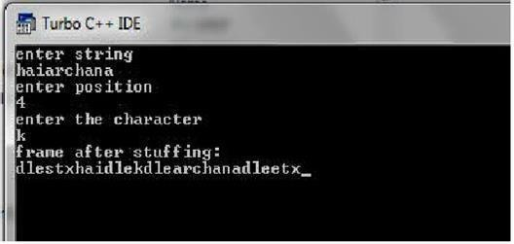

Viva Questions:
- What is Character stuffing?
- What is the use of character stuffing?
- ---------- are the delimiters for the character stuffing.
- Expand DLE STX?
- Expand DLE ETX?

EXPERIMENT NO: 10 c) NAME OF THE EXPERIMENT: Shortest Path.

OBJECTIVE: Implement Dijkstra‘ s algorithm to compute the Shortest path through a given graph.
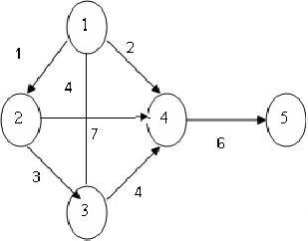

RESOURCE: Turbo C

Program Logic: Dijkstra's algorithm is very similar to Prim's algorithm for minimum spanning tree. Like Prim's MST, we generate a SPT (shortest path tree) with given source as root. We maintain two sets, one set contains vertices included in shortest path tree, and other set includes vertices not yet included in shortest path tree.
PROCEDURE: Go to debug -> run or press CTRL + F9 to run the program.

SOURCE CODE:
// .PROGRAM FOR FINDING SHORTEST PATH FOR A GIVEN GRAPH//

#include<stdio.h> #include<conio.h> void main()
{
int path[5][5],i,j,min,a[5][5],p,st=1,ed=5,stp,edp,t[5],index; clrscr();
printf("enter the cost Matrix\n"); for(i=1;i<=5;i++)
for(j=1;j<=5;j++)
scanf("%d",&a[i][j]);
printf("enter the paths\n"); scanf("%d",&p);
printf("enter possible paths\n"); for(i=1;i<=p;i++)
for(j=1;j<=5;j++) scanf("%d",&path[i][j]);
for(i=1;i<=p;i++)
{ t[i]=0;

stp=st; for(j=1;j<=5;j++)
{
edp=path[i][j+1]; t[i]=t[i]+a[stp][edp]; if(edp==ed)
break; else stp=edp;
}
}min=t[st]; index=st; for(i=1;i<=p;i++)
{
if(min>t[i])
{
min=t[i]; index=i;
}
}
printf("minimum cost %d",min); printf("\n minimum cost path "); for(i=1;i<=5;i++)
{
printf("--> %d",path[index][i]); if(path[index][i]==ed)
break;
}
getch();
}
Output:
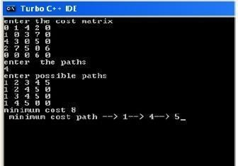

Viva questions:

- Define Dijkstra’s algorithm?
- What is the use of Dijkstra’s algorithm?
- What is path?
- What is minimum cost path?
- How to find shortest path using Dijkstra’s algorithm?

EXPERIMENT NO 10 d) :NAME OF THE EXPERIMENT: Distance Vector routing.
OBJECTIVE: Obtain Routing table at each node using distance vector routing algorithm for a given
subnet.

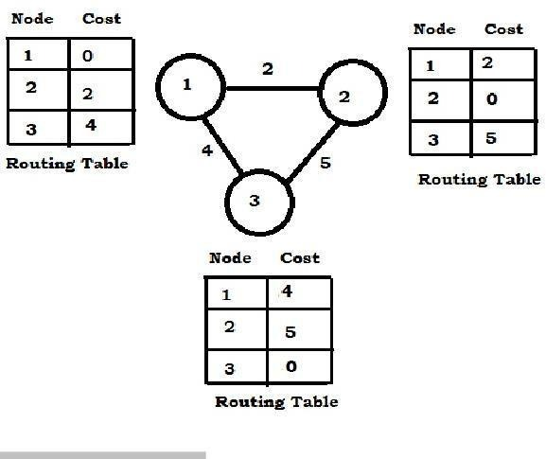

RESOURCE: Turbo C

PROGRAM LOGIC:
Distance Vector Routing Algorithms calculate a best route to reach a destination based solely on distance. E.g. RIP. RIP calculates the reach ability based on hop count. It’s different from link state algorithms which consider some other factors like bandwidth and other metrics to reach a destination. Distance vector routing algorithms are not preferable for complex networks and take longer to converge.
PROCEDURE: Go to debug -> run or press CTRL + F9 to run the program.

SOURCE CODE:
#include<stdio.h> #include<conio.h> struct node
{
unsigned dist[20]; unsigned from[20]; }
rt[10];
int main()
{
int dmat[20][20]; int n,i,j,k,count=0; clrscr();
printf("\nEnter the number of nodes : "); scanf("%d",&n);printf("Enter the cost matrix :\n"); for(i=0;i<n;i++)
for(j=0;j<n;j++)
{
scanf("%d",&dmat[i][j]); dmat[i][i]=0; rt[i].dist[j]=dmat[i][j]; rt[i].from[j]=j;
}
Do
{
count=0; for(i=0;i<n;i++) for(j=0;j<n;j++) for(k=0;k<n;k++)
if(rt[i].dist[j]>dmat[i][k]+rt[k].dist[j])
{
rt[i].dist[j]=rt[i].dist[k]+rt[k].dist[j]; rt[i].from[j]=k;count++;
}
}while(count!=0); for(i=0;i<n;i++)
{
printf("\nState value for router %d is \n",i+1); for(j=0;j<n;j++)
{
printf("\nnode %d via %d Distance%d",j+1,rt[i].from[j]+1,rt[i].dist[j]);
}
}
printf(“\n”);
}
Output: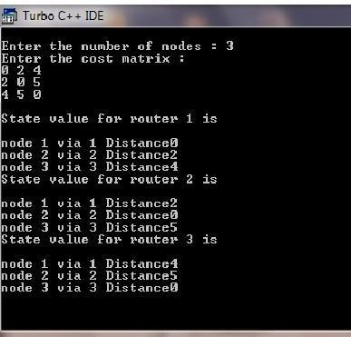

Viva Questions:
- What is routing?
- What is best algorithm among all routing algorithms?
- What is static routing?
- Differences between static and dynamic?
- What is optimality principle?

Experiment beyond the syllabus

Configuring Ethernet and Serial Interfaces

Topology Diagram
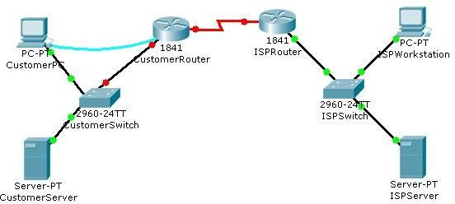

Objectives
- Configure a LAN Ethernet interface.
- Configure a WAN serial interface.
- Verify the interface configurations.

Background / Preparation
In this activity, you will configure the LAN Ethernet interface and the WAN serial interface on the Customer Cisco 1841 router.

Procedure:

Step 1: Configure the LAN Ethernet interface.
- Use the terminal emulation software on the Customer PC to connect to the Cisco 1841 Customer Router. Enter cisco for the console password.
- Enter privileged EXEC mode using cisco123 for the privileged EXEC password. The CustomerRouter# prompt indicates that you are in privileged EXEC mode.
- Enter global configuration mode. The CustomerRouter(config)# prompt indicates that you are in global configuration mode.
- Identify which LAN interface to configure with an IP address. To configure the Fast Ethernet interface, use this command.

CustomerRouter(config)#interface FastEthernet 0/0
Add a description to the interface.

CustomerRouter(config-if)#description Connected to CustomerSwitch Specify the IP address and subnet mask for the interface.

CustomerRouter(config-if)#ip address 192.168.1.1 255.255.255.0

Ensure that the interface is enabled.

CustomerRouter(config-if)#no shutdown

Exit interface configuration mode.

CustomerRouter(config-if)#end

Step 2: Verify the LAN interface configuration.

Use the show ip route command to verify your configuration. This is a partial example of the output.

CustomerRouter#show ip route

<output omitted>

Gateway of last resort is not set
C 192.168.1.0/24 is directly connected, FastEthernet0/0

Step 3: Configure the WAN serial interface.
Refer to the diagram in the Packet Tracer workspace area and the commands used in Step 1 to configure the WAN serial interface on Customer Router.
Tip: Remember the Cisco IOS CLI Help commands to configure the interface.

- Enter global configuration mode.
- Identify the serial interface to configure.
- Describe the interface. (Connected to ISP)
- Specify the interface IP address and subnet mask. (209.165.200.225 255.255.255.224)
- Ensure that the interface is enabled.
- End interface configuration mode.

Step 4: Verify the interface configurations.
Use the show run command to verify your configuration. This is a partial example of the output.

CustomerRouter#show run
...
!
interface FastEthernet0/0
description Connected to CustomerSwitch ip address 192.168.1.1 255.255.255.0
duplex auto speed auto
!
interface FastEthernet0/1 no ip address
duplex auto speed auto shutdown
!
interface Serial0/1/0 description Connected to ISP
ip address 209.165.200.225 255.255.255.224
!

Use the ping command to verify connectivity to the WAN interface on the ISP router. This is a partial example of the output.

CustomerRouter#ping 209.165.200.226

Type escape sequence to abort.
Sending 5, 100-byte ICMP Echos to 209.165.200.226, timeout is 2 seconds:
!!!!!
Success rate is 100 percent (5/5), round-trip min/avg/max = 35/37/47 ms

Use the ping command to verify connectivity to the customer switch. This is a partial example of the output.

CustomerRouter#ping 192.168.1.1
Type escape sequence to abort.
Sending 5, 100-byte ICMP Echos to 192.168.1.1, timeout is 2 seconds:
!!!!!
Success rate is 100 percent (5/5), round-trip min/avg/max = 0/5/12 ms

Step 5: Save the configuration.
- In privileged EXEC mode, save the running configuration to the startup configuration.

CustomerRouter#copy run start

- Click the Check Results button at the bottom of this instruction window to check your work.

Reflection

- When you ping the LAN IP address of the ISP router, what happens and why?

- Which of the following Cisco ISO CLI modes do you need to be in to configure the description of an interface?
  - CustomerRouter#
  - CustomerRouter>
  - CustomerRouter(config)#
  - CustomerRouter(config-if)#
- You configured the Fast Ethernet 0/0 interface with the no shutdown command and verified the configuration. However, when you rebooted the router, the interface was shutdown. You reconfigured the Fast Ethernet 0/0 interface and verified that the configuration works. Explain what most likely happened.

Simulate experiments using
NS2/NS3/NCTUNS/NetSim/
or any other equivalent tool.

EXPT.NO.1 | STUDY OF NETWORK SIMULATOR (NS)
DATE:

AIM:
To study about NS2 simulator in detail.

THEORY:
Network Simulator (Version 2), widely known as NS2, is simply an event driven simulation tool that has proved useful in studying the dynamic nature of communication networks. Simulation of wired as well as wireless network functions and protocols (e.g., routing algorithms, TCP, UDP) can be done using NS2. In general, NS2 provides users with a way of specifying such network protocols and simulating their corresponding behaviors. Due to its flexibility and modular nature, NS2 has gained constant popularity in the networking research community since its birth in 1989. Ever since, several revolutions and revisions have marked the growing maturity of the tool, thanks to substantial contributions from the players in the field. Among these are the University of California and Cornell University who developed the REAL network simulator,1 the foundation which NS is based on. Since 1995 the Defense Advanced Research Projects Agency (DARPA) supported development of NS through the Virtual Inter Network Testbed (VINT) project . Currently the National Science Foundation (NSF) has joined the ride in development. Last but not the least, the group of Researchers and developers in the community are constantly working to keep NS2 strong and versatile.

BASIC ARCHITECTURE:
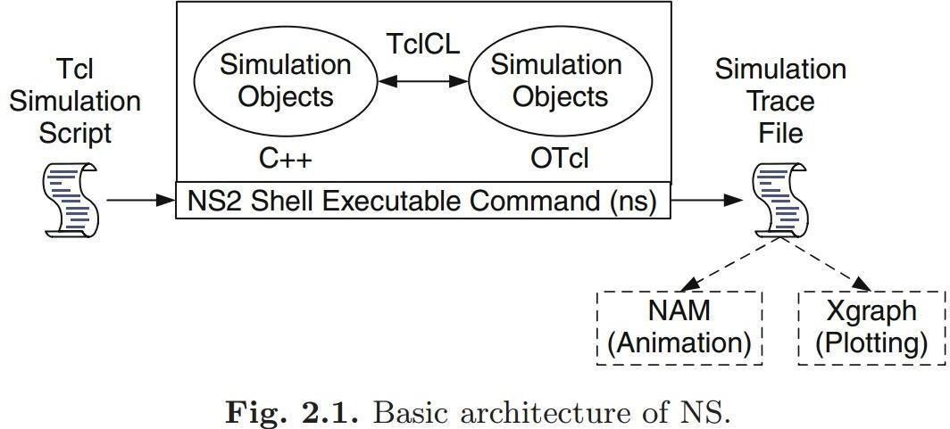
Figure 2.1 shows the basic architecture of NS2. NS2 provides users with an executable command ns which takes on input argument, the name of a TCL simulation scripting file. Users are feeding the name of a TCL simulation script (which sets up a simulation) as an input argument of an NS2 executable command ns.

In most cases, a simulation trace file is created, and is used to plot graph and/or to create animation. NS2 consists of two key languages: C++ and Object-oriented Tool Command Language (OTcl). While the C++ defines the internal mechanism (i.e., a backend) of the simulation objects, the OTcl sets up simulation by assembling and configuring the objects as well as scheduling discrete events (i.e., a frontend).

The C++ and the OTcl are linked together using TclCL. Mapped to a C++ object, variables in the OTcl domains are sometimes referred to as handles. Conceptually, a handle (e.g., n as a Node handle) is just a string (e.g., _o10) in the OTcl domain, and does not contain any functionality. Instead, the functionality (e.g., receiving a packet) is defined in the mapped C++ object (e.g., of class Connector). In the OTcl domain, a handle acts as a frontend which interacts with users and other OTcl objects. It may defines its own procedures and variables to facilitate the interaction. Note that the member procedures and variables in the OTcl domain are called instance procedures (instprocs) and instance variables (instvars), respectively. Before proceeding further, the readers are encouraged to learn C++ and OTcl languages. We refer the readers to [14] for the detail of C++, while a brief tutorial of Tcl and OTcl tutorial are given in Appendices A.1 and A.2, respectively.
NS2 provides a large number of built-in C++ objects. It is advisable to use these C++ objects to set up a simulation using a Tcl simulation script. However, advance users may find these objects insufficient. They need to develop their own C++ objects, and use a OTcl configuration interface to put together these objects. After simulation, NS2 outputs either text-based or animation-based simulation results. To interpret these results graphically and interactively, tools such as NAM (Network AniMator) and XGraph are used. To analyze a particular behaviour of the network, users can extract a relevant subset of text-based data and transform it to a more conceivable presentation.

CONCEPT OVERVIEW

NS uses two languages because simulator has two different kinds of things it needs to do. On one hand, detailed simulations of protocols requires a systems programming language which can efficiently manipulate bytes, packet headers, and implement algorithms that run over large data sets. For these tasks run-time speed is important and turn-around time (run simulation, find bug, fix bug, recompile, re-run) is less important. On the other hand, a large part of network research involves slightly varying parameters or configurations, or quickly exploring a number of scenarios.
In these cases, iteration time (change the model and re-run) is more important. Since configuration runs once (at the beginning of the simulation), run-time of this part of the task is less important. ns meets both of these needs with two languages, C++ and OTcl.

TCL scripting
TCL is a general purpose scripting language. [Interpreter]
- TCL runs on most of the platforms such as Unix, Windows, and Mac.
- The strength of TCL is its simplicity.
- It is not necessary to declare a data type for variable prior to the usage.

Basics of TCL
Syntax: command arg1 arg2 arg3

Hello World!
puts stdout{Hello, World!} Hello, World!

Variables Command Substitution set a 5 set len [string length foobar]
set b $a set len [expr [string length foobar] + 9]

Wired TCL Script Components

Create the event scheduler
Open new files & turn on the tracing Create the nodes
Setup the links
Configure the traffic type (e.g., TCP, UDP, etc)
Set the time of traffic generation (e.g., CBR, FTP) Terminate the simulation

NS Simulator Preliminaries.

- Initialization and termination aspects of the ns simulator.
- Definition of network nodes, links, queues and topology.
- Definition of agents and of applications.
- The Nam (Network Animator) visualization tool.
- Tracing and random variables.

Initialization and Termination of TCL Script in NS-2
An ns simulation starts with the command

set ns [new Simulator]

Which is thus the first line in the TCL script. This line declares a new variable as using the set command, you can call this variable as you wish, In general people declares it as ns because it is an instance of the Simulator class, so an object the code[new Simulator] is indeed the installation of the class Simulator using the reserved word new.

In order to have output files with data on the simulation (trace files) or files used for visualization (nam files), we need to create the files using ―open command:

#Open the Trace file
set tracefile1 [open out.tr w]

$ns trace-all $tracefile1

#Open the NAM trace file

set namfile [open out.nam w]
$ns namtrace-all $namfile
The above creates a dta trace file called out.tr and a nam visualization trace file called out.nam.
Within the tcl script, these files are not called explicitly by their names, but instead by pointers that are declared above and called ―tracefile1 and ―namfile respectively. Remark that they begins with a # symbol. The second line open the file ―out.tr to be used for writing, declared with the letter ―w. The third line uses a simulator method called trace-all that have as parameter the name of the file where the traces will go.
Define a “finish” procedure
Proc finish {}
{
global ns tracefile1 namfile
$ns flush-trace
Close $tracefile1
Close $namfile
Exec nam out.nam & Exit 0

}

Definition of a network of links and nodes
The way to define a node is

set n0 [$ns node]

Once we define several nodes, we can define the links that connect them. An example of a definition of a link is:

$ns duplex-link $n0 $n2 10Mb 10ms DropTail

Which means that $n0 and $n2 are connected using a bi-directional link that has 10ms of propagation delay and a capacity of 10Mb per sec for each direction.
To define a directional link instead of a bi-directional one, we should replace ―duplex-link by
―simplex-link.
In ns, an output queue of a node is implemented as a part of each link whose input is that node. We should also define the buffer capacity of the queue related to each link. An example would be:

#set Queue Size of link (n0-n2) to 20
$ns queue-limit $n0 $n2 20

FTP over TCP
TCP is a dynamic reliable congestion control protocol. It uses Acknowledgements created by the destination to know whether packets are well received.
There are number variants of the TCP protocol, such as Tahoe, Reno, NewReno, Vegas. The type of agent appears in the first line:

set tcp [new Agent/TCP]

The command $ns attach-agent $n0 $tcp defines the source node of the tcp connection.
The command set sink [new Agent /TCPSink] Defines the behavior of the destination node of TCP and assigns to it a pointer called sink.
#Setup a UDP Connection
Set udp [new Agent/UDP]
$ns attach-agent $n1 $udp set null [new Agent/Null]

$ns attach-agent $n5 $null
$ns connect $udp $null
$udp set fid_2

#setup a CBR over UDP connection
The below shows the definition of a CBR application using a UDP agent
The command $ns attach-agent $n4 $sink defines the destination node. The command $ns connect
$tcp $sink finally makes the TCP connection between the source and destination nodes.

set cbr [new Application/Traffic/CBR]
$cbr attach-agent $udp

$cbr set packetsize_ 100
$cbr set rate_ 0.01Mb

$cbr set random_ false

TCP has many parameters with initial fixed defaults values that can be changed if mentioned explicitly. For example, the default TCP packet size has a size of 1000bytes.This can be changed to another value, say 552bytes, using the command $tcp set packetSize_ 552.
When we have several flows, we may wish to distinguish them so that we can identify them with different colors in the visualization part. This is done by the command $tcp set fid_ 1 that assigns to the TCP connection a flow identification of ―1.We shall later give the flow identification of ―2‖ to the UDP connection.

VIVA QUES VIVA QUESTIONS:

- What protocols does ns support?
- What Is Simulation?
- Define Network
- What is meant by Protocol?
- What are the constituent parts of NS2?

RESULT:

Thus the Network Simulator 2 is studied in detail.

EXPT.NO 2 | NETWORK TOPOLOGY BUS TOPOLOGY
DATE:

AIM:
To create scenario and study the performance of token bus protocol through simulation.

HARDWARE / SOFTWARE REQUIREMENTS:

NS-2

THEORY:
Token bus is a LAN protocol operating in the MAC layer. Token bus is standardized as per IEEE 802.4. Token bus can operate at speeds of 5Mbps, 10 Mbps and 20 Mbps. The operation of token bus is as follows: Unlike token ring in token bus the ring topology is virtually created and maintained by the protocol. A node can receive data even if it is not part of the virtual ring, a node joins the virtual ring only if it has data to transmit. In token bus data is transmitted to the destination node only where as other control frames is hop to hop. After each data transmission there is a solicit_successsor control frame transmitted which reduces the performance of the protocol.

ALGORITHM:

- Create a simulator object
- Define different colors for different data flows
- Open a nam trace file and define finish procedure then close the trace file, and execute nam on trace file.
- Create five nodes that forms a network numbered from 0 to 4
- Create duplex links between the nodes and add Orientation to the nodes for setting a LAN topology
- Setup TCP Connection between n(1) and n(3)
- Apply CBR Traffic over TCP.
- Schedule events and run the program.

PROGRAM:

#Create a simulator object
set ns [new Simulator]

#Open the nam trace file set nf [open out.nam w]
$ns namtrace-all $nf

#Define a 'finish' procedure
proc finish { }
{
global ns nf
$ns flush-trace #Close the trace file close $nf
#Executenam on the trace file exec nam out.nam &
exit 0
}
#Create five nodes set n0 [$ns node] set n1 [$ns node] set n2 [$ns node] set n3 [$ns node] set n4 [$ns node]

#Create Lan between the nodes
set lan0
[$ns newLan "$n0 $n1 $n2 $n3 $n4" 0.5Mb 40ms LL Queue/DropTail MAC/Csma/Cd Channel]

#Create a TCP agent and attach it to node n0 set tcp0
[new Agent/TCP]
$tcp0 set class_ 1
$ns attach-agent $n1 $tcp0
#Create a TCP Sink agent (a traffic sink) for TCP and attach it to node n3 set sink0 [new Agent/TCPSink]
$ns attach-agent $n3 $sink0
#Connect the traffic sources with the traffic sink
$ns connect $tcp0 $sink0

# Create a CBR traffic source and attach it to tcp0 set cbr0
[new Application/Traffic/CBR]
$cbr0 set packetSize_ 500
$cbr0 set interval_ 0.01
$cbr0 attach-agent $tcp0

#Schedule events for the CBR agents
$ns at 0.5 "$cbr0 start"
$ns at 4.5 "$cbr0 stop"

#Call the finish procedure after 5 seconds of simulation time
$ns at 5.0 "finish"

#Run the simulation
$ns run

OUTPUT:
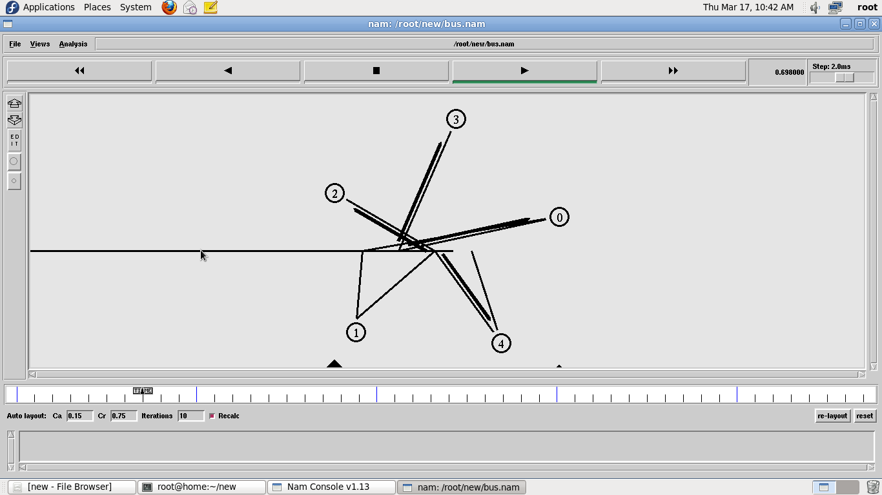
RESULT:
Thus the Bus Topology was Simulated and studied.

EXPT.NO.3 | NETWORK TOPOLOGY RING TOPOLOGY
DATE:

AIM:
To create scenario and study the performance of token ring protocols through simulation.

HARDWARE / SOFTWARE REQUIREMENTS: NS-2

THEORY:
Token ring is a LAN protocol operating in the MAC layer. Token ring is standardized as per IEEE 802.5. Token ring can operate at speeds of 4mbps and 16 mbps. The operation of token ring is as follows: When there is no traffic on the network a simple 3-byte token circulates the ring. If the token is free (no reserved by a station of higher priority as explained later) then the station may seize the token and start sending the data frame. As the frame travels around the ring ach station examines the destination address and is either forwarded (if the recipient is another node) or copied. After copying4 bits of the last byte is changed. This packet then continues around the ring till it reaches the originating station. After the frame makes a round trip the sender receives the frame and releases a new token onto the ring.

ALGORITHM:

- Create a simulator object
- Define different colors for different data flows
- Open a nam trace file and define finish procedure then close the trace file, and execute nam on trace file.
- Create five nodes that forms a network numbered from 0 to 4
- Create duplex links between the nodes to form a Ring Topology.
- Setup TCP Connection between n(1) and n(3)
- Apply CBR Traffic over TCP
- Schedule events and run the program.

PROGRAM:

#Create a simulator object
set ns [new Simulator]

#Open the nam trace file
set nf [open out.nam w]
$ns namtrace-all $nf

#Define a 'finish' procedure
proc finish {} {
global ns nf
$ns flush-trace #Close the trace file close $nf
#Executenam on the trace file exec nam out.nam &
exit0
}

#Create five nodes set n0 [$ns node] set n1 [$ns node] set n2 [$ns node] set n3 [$ns node] set n4 [$ns node] set n5 [$ns node]
#Create links between the nodes
$ns duplex-link $n0 $n1 1Mb 10ms DropTail
$ns duplex-link $n1 $n2 1Mb 10ms DropTail
$ns duplex-link $n2 $n3 1Mb 10ms DropTail
$ns duplex-link $n3 $n4 1Mb 10ms DropTail
$ns duplex-link $n4 $n5 1Mb 10ms DropTail
$ns duplex-link $n5 $n0 1Mb 10ms DropTail

#Create a TCP agent and attach it to node n0 set tcp0 [new Agent/TCP]
$tcp0 set class_ 1
$ns attach-agent $n1 $tcp0
#Create a TCP Sink agent (a traffic sink) for TCP and attach it to node n3 set sink0 [new Agent/TCPSink]
$ns attach-agent $n3 $sink0
#Connect the traffic sources with the traffic sink
$ns connect $tcp0 $sink0

# Create a CBR traffic source and attach it to tcp0 set cbr0
[new Application/Traffic/CBR]
$cbr0 set packetSize_ 500
$cbr0 set interval_ 0.01
$cbr0 attach-agent $tcp0

#Schedule events for the CBR agents
$ns at 0.5 "$cbr0 start"
$ns at 4.5 "$cbr0 stop"

#Call the finish procedure after 5 seconds of simulation time
$ns at 5.0 "finish"

#Run the simulation
$ns run

OUTPUT:
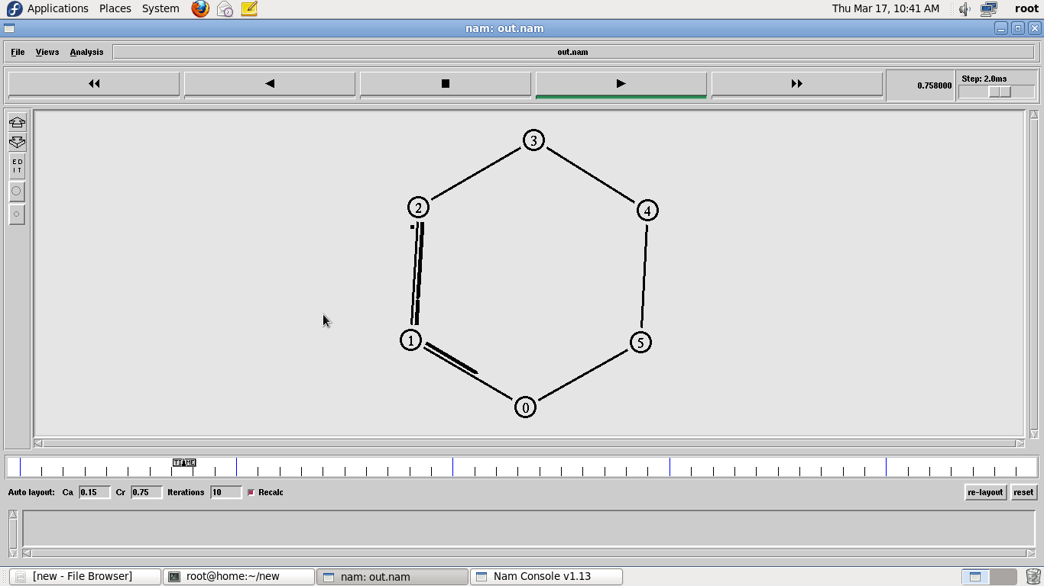
RESULT:
Thus the Ring Topology was simulated and studied.

EXPT.NO.4 | NETWORK TOPOLOGY STAR TOPOLOGY
DATE:

AIM:
To create scenario and study the performance of token ring protocols through simulation.

HARDWARE / SOFTWARE REQUIREMENTS: NS-2

THEORY:
Star networks are one of the most common computer network topologies. In its simplest form, a star network consists of one central switch, hub or computer, which acts as a conduit to transmit messages. This consists of a central node, to which all other nodes are connected; this central node provides a common connection point for all nodes through a hub. In star topology, every node (computer workstation or any other peripheral) is connected to a central node called a hub or switch. The switch is the server and the peripherals are the clients. Thus, the hub and leaf nodes, and the transmission lines between them, form a graph with the topology of a star. If the central node is passive, the originating node must be able to tolerate the reception of an echo of its own transmission, delayed by the two-way transmission time (i.e. to and from the central node) plus any delay generated in the central node. An active star network has an active central node that usually has the means to prevent echo-related problems.

The star topology reduces the damage caused by line failure by connecting all of the systems to a central node. When applied to a bus-based network, this central hub rebroadcasts all transmissions received from any peripheral node to all peripheral nodes on the network, sometimes including the originating node. All peripheral nodes may thus communicate with all others by transmitting to, and receiving from, the central node only. The failure of a transmission line linking any peripheral node to the central node will result in the isolation of that peripheral node from all others, but the rest of the systems will be unaffected.

ALGORITHM:

- Create a simulator object
- Define different colors for different data flows
- Open a nam trace file and define finish procedure then close the trace file, and execute nam on trace file.
- Create six nodes that forms a network numbered from 0 to 5
- Create duplex links between the nodes to form a STAR Topology
- Setup TCP Connection between n(1) and n(3)
- Apply CBR Traffic over TCP
- Schedule events and run the program.

PROGRAM:

#Create a simulator object
set ns [new Simulator]

#Open the nam trace file
set nf [open out.nam w]
$ns namtrace-all $nf

#Define a 'finish' procedure
proc finish {} {
global ns nf

$ns flush-trace
#Close the trace file
close $nf
#Executenam on the trace file exec nam out.nam &
exit0
}
#Create six nodes
set n0 [$ns node]
set n1 [$ns node]
set n2 [$ns node]
set n3 [$ns node]
set n4 [$ns node]
set n5 [$ns node]

#Change the shape of center node in a star topology
$n0 shape square

#Create links between the nodes
$ns duplex-link $n0 $n1 1Mb 10ms DropTail
$ns duplex-link $n0 $n2 1Mb 10ms DropTail
$ns duplex-link $n0 $n3 1Mb 10ms DropTail
$ns duplex-link $n0 $n4 1Mb 10ms DropTail
$ns duplex-link $n0 $n5 1Mb 10ms DropTail

#Create a TCP agent and attach it to node n0 set tcp0 [new Agent/TCP]
$tcp0 set class_ 1
$ns attach-agent $n1 $tcp0
#Create a TCP Sink agent (a traffic sink) for TCP and attach it to node n3
set sink0 [new Agent/TCPSink]
$ns attach-agent $n3 $sink0
#Connect the traffic sources with the traffic sink
$ns connect $tcp0 $sink0
# Create a CBR traffic source and attach it to tcp0
set cbr0 [new Application/Traffic/CBR]
$cbr0 set packetSize_ 500
$cbr0 set interval_ 0.01
$cbr0 attach-agent $tcp0
#Schedule events for the CBR agents
$ns at 0.5 "$cbr0 start"
$ns at 4.5 "$cbr0 stop"
#Call the finish procedure after 5 seconds of simulation time
$ns at 5.0 "finish" #Run the simulation
$ns run

OUTPUT:
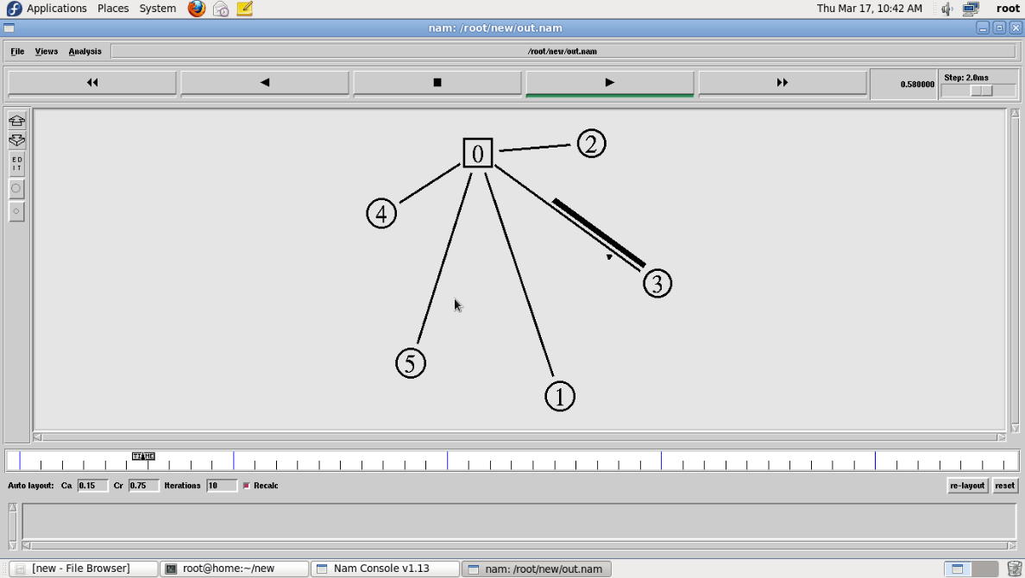
VIVA QUESTIONS:

1. What are the Different topologies available in networks?
2. Which topology requires multipoint connection?
3. Data communication system with in a campus is called as?
4. What is meant by WAN?
5. Explain the working of Ring topology?

RESULT:

Thus the star Topology was simulated and studied.

EXPT.NO.5 | SIMULATION OF LINK STATE ROUTING ALGORITHM
DATE:

AIM:
To simulate and study the link state routing algorithm using simulation.

SOFTWARE REQUIRED:
NS-2

THEORY:
In link state routing, each router shares its knowledge of its neighborhood with every other router in the internet work. (i) Knowledge about Neighborhood: Instead of sending its entire routing table a router sends info about its neighborhood only. (ii) To all Routers: each router sends this information to every other router on the internet work not just to its neighbor .It does so by a process called flooding. (iii)Information sharing when there is a change: Each router sends out information about the neighbors when there is change.

PROCEDURE:

The Dijkstra algorithm follows four steps to discover what is called the shortest path tree(routing table) for each router:The algorithm begins to build the tree by identifying its roots. The root router’s trees the router itself. The algorithm then attaches all nodes that can be reached from the root. The algorithm compares the tree’s temporary arcs and identifies the arc with the lowest cumulative cost. This arc and the node to which it connects are now a permanent part of the shortest path tree. The algorithm examines the database and identifies every node that can be reached from its chosen node. These nodes and their arcs are added temporarily to the tree.
The last two steps are repeated until every node in the network has become a permanent part of the tree.

ALGORITHM:

- Create a simulator object
- Define different colors for different data flows
- Open a nam trace file and define finish procedure then close the trace file, and execute nam on trace file.
- Create n number of nodes using for loop
- Create duplex links between the nodes
- Setup UDP Connection between n(0) and n(5)
- Setup another UDP connection between n(1) and n(5)
- Apply CBR Traffic over both UDP connections
- Choose Link state routing protocol to transmit data from sender to receiver.
- Schedule events and run the program.

PROGRAM:

set ns [new Simulator] set nr [open thro.tr w]
$ns trace-all $nr
set nf [open thro.nam w]
$ns namtrace-all $nf proc finish { }
{ global ns nr nf
$ns flush-trace close $nf
close $nr

exec nam thro.nam & exit 0
}

for { set i 0 } { $i < 12} { incr i 1 } { set n($i) [$ns node]}
for {set i 0} {$i < 8} {incr i} {
$ns duplex-link $n($i) $n([expr $i+1]) 1Mb 10ms DropTail }
$ns duplex-link $n(0) $n(8) 1Mb 10ms DropTail
$ns duplex-link $n(1) $n(10) 1Mb 10ms DropTail
$ns duplex-link $n(0) $n(9) 1Mb 10ms DropTail
$ns duplex-link $n(9) $n(11) 1Mb 10ms DropTail
$ns duplex-link $n(10) $n(11) 1Mb 10ms DropTail
$ns duplex-link $n(11) $n(5) 1Mb 10ms DropTail
set udp0 [new Agent/UDP]
$ns attach-agent $n(0) $udp0
set cbr0 [new Application/Traffic/CBR]
$cbr0 set packetSize_ 500
$cbr0 set interval_ 0.005
$cbr0 attach-agent $udp0 set null0 [new Agent/Null]
$ns attach-agent $n(5) $null0
$ns connect $udp0 $null0
set udp1 [new Agent/UDP]
$ns attach-agent $n(1) $udp1
set cbr1 [new Application/Traffic/CBR]
$cbr1 set packetSize_ 500
$cbr1 set interval_ 0.005
$cbr1 attach-agent $udp1 set null0 [new Agent/Null]
$ns attach-agent $n(5) $null0
$ns connect $udp1 $null0
$ns rtproto LS
$ns rtmodel-at 10.0 down $n(11) $n(5)
$ns rtmodel-at 15.0 down $n(7) $n(6)
$ns rtmodel-at 30.0 up $n(11) $n(5)
$ns rtmodel-at 20.0 up $n(7) $n(6)
$udp0 set fid_ 1
$udp1 set fid_ 2
$ns color 1 Red
$ns color 2 Green
$ns at 1.0 "$cbr0 start"
$ns at 2.0 "$cbr1 start"
$ns at 45 "finish"
$ns run

OUTPUT:
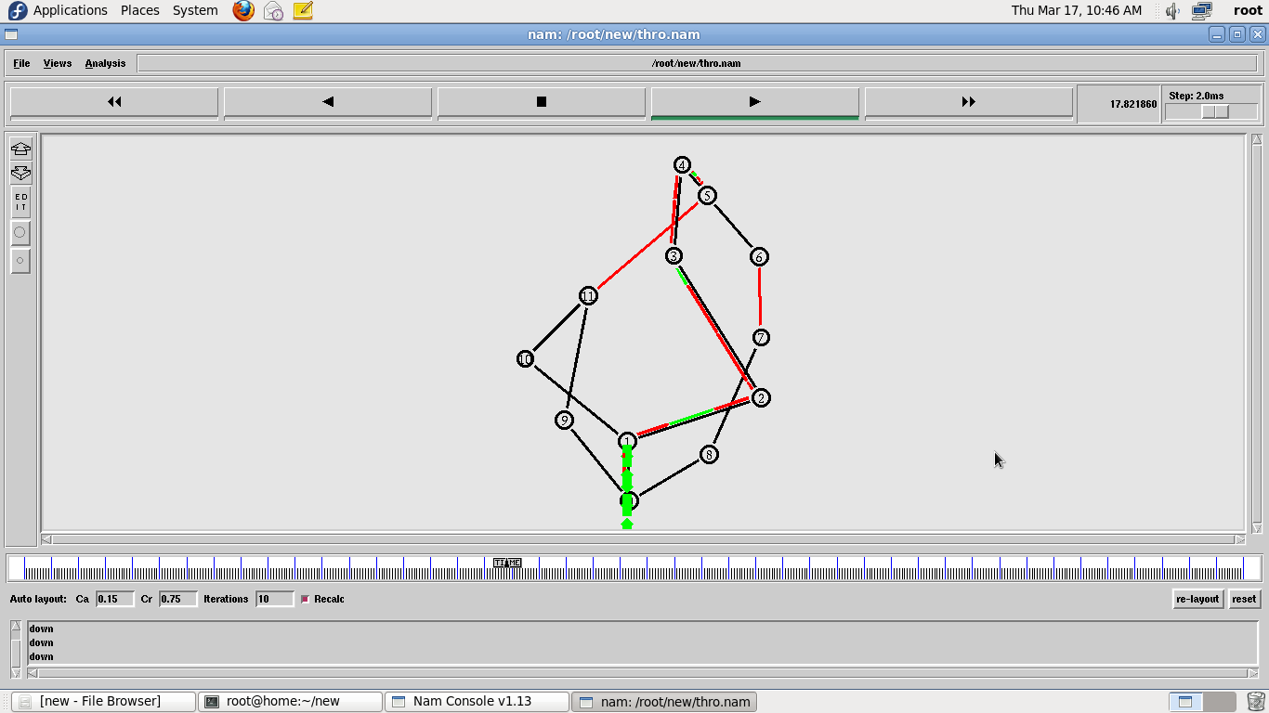
VIVA QUESTIONS:

- What is Routing?
- What is Dynamic rouitng?
- What are the two steps in link state routing?
- Compare link state and Distance Vector routing
- What are all the route metric used in Link state routing?

Network Simulator 2:
SIMULATION-INTRODUCTION

Network simulation is an important tool in developing, testing and evaluating network protocols. Simulation can be used without the target physical hardware, making it economical and practical for almost any scale of network topology and setup. It is possible to simulate a link of any bandwidth and delay, even if such a link is currently impossible in the real world. With simulation, it is possible to set each simulated node to use any desired software. This means that meaning deploying software is not an issue. Results are also easier to obtain and analyze, because extracting information from important points in the simulated network is as done by simply parsing the generated trace files.
Simulation is only of use if the results are accurate, an inaccurate simulator is not useful at all. Most network simulators use abstractions of network protocols, rather than the real thing, making their results less convincing. S.Y. Wang reports that the simulator OPNET uses a simplified finite state machine to model complex TCP protocol processing. [19] NS-2 uses a model based on BSD TCP, it is implemented as a set of classes using inheritance. Neither uses protocol code that is used in real world networking.

Setting up the environment

A user using the NCTUns in single machine mode, needs to do the following steps before he/she starts the GUI program:
- Set up environment variables:
Before the user can run up the dispatcher, coordinator, or NCTUns GUI program he/she must set up the NCTUNSHOME environment variable.
- Start up the dispatcher on terminal 1.
- Start up the coordinator on terminal 2.
- Start up the nctuns client on terminal 3.
After the above steps are followed, the starting screen of NCTUns disappears and the user is presented with the working window as shown below:

Drawing A Network Topology

To draw a new network topology, a user can perform the following steps:
Choose Menu->File->Operating Mode-> and make sure that the “Draw Topology” mode is checked. This is the default mode of NCTUns when it is launched. It is only in this mode that a user can draw a new network topology or change an existing simulation topology. When a user switches the mode to the next mode “Edit Property”, the simulation network topology can no longer be changed.
- Move the cursor to the toolbar.
- Left-Click the router icon on the toolbar.
- Left-Click anywhere in the blank working area to add a router to the current network topology. In the same way we can add switch, hub, WLAN access point, WLAN mobile node , wall (wireless signal obstacle) etc.
- Left-Click the host icon on the toolbar. Like in step 4, add the required number of hosts to the current topology.
- To add links between the hosts and the router, left-click the link icon on the toolbar to select it.
- Left-Click a host and hold the mouse button. Drag this link to the router and then release the mouse left button on top of the router. Now a link between the selected host and the router has been created.

- Add the other, required number of links in the same way. This completes the creation of a simple network topology.
- Save this network topology by choosing Menu->File->Save. It is saved with a .tpl extension.
- Take the snapshot of the above topology.

Editing Node's Properties
- A network node (device) may have many parameters to set. For example, we may have to set the maximum bandwidth, maximum queue size etc to be used in a network interface. For another example, we may want to specify that some application programs (traffic generators) should be run on some hosts or routers to generate network traffic.
- Before a user can start editing the properties of a node, he/she should switch the mode from the “Draw Topology” to “Edit Property” mode. In this mode, topology changes can no longer be made. That is, a user cannot add or delete nodes or links at this time.

- The GUI automatically finds subnets in a network and generates and assigns IP and MAC addresses to layer 3 network interfaces.

- A user should be aware that if he/she switches the mode back to the “Draw Topology” mode when he/she again switches the mode back to the “Edit Topology” mode, node's IP and MAC addresses will be regenerated and assigned to layer 3 interfaces.

Therefore the application programs now may use wrong IP addresses to communicate with their partners.

Running the Simulation

When a user finishes editing the properties of network nodes and specifying application programs to be executed during a simulation, he/she can start running the simulation.
- In order to do so, the user must switch mode explicitly from “Edit Property” to “Run Simulation”. Entering this mode indicates that no more changes can (should) be made to the simulation case, which is reasonable. This simulation is about to be started at this moment; of course, any of its settings should be fixed.

- Whenever the mode is switched to the “ Run Simulation” mode, the many simulation files that collectively describe the simulation case will be exported. These simulation files will be transferred to the (either remote or local) simulation server for it to execute the simulation. These files are stored in the “ main File Name.sim” directory, where main Filename is the name of the simulation case chosen in the “Draw Topology” mode.

Playing Back the Packet Animation Trace

After the simulation is finished, the simulation server will send back the simulation result files to the GUI program after receiving these files, the GUI program will store these files in the “results directory” .It will then automatically switch to “play back mode”.
- These files include a packet animation trace file and all performance log files that the user specifies to generate. Outputting these performance log files can be specified by checking some output options in some protocol modules in the node editor. In addition to this, application programs can generate their own data files.

- The packet animation trace file can be replayed later by the packet animation player. The performance curve of these log files can be plotted by the performance monitor.

Post Analysis
- When the user wants to review the simulation results of a simulation case that has been finished before, he /she can run up the GUI program again and then open the case's topology file.
- The user can switch the mode directly to the “Play Back” mode. The GUI program will then automatically reload the results (including the packet animation trace file and performance log file.
- After the loading process is finished, the user can use the control buttons located at the bottom of the screen to view the animation.

Simulation Commands

Run: Start to run simulation.
- Pause: Pause the currently -running simulation.
- Continue: Continue the simulation that was just paused.
- Stop: Stop the currently -running simulation
- Abort: Abort the currently running simulation.The difference between “stop” and “abort” is that a stopped simulation job's partial results will be
transferred back to GUI files.
- Reconnect: The Reconnect command can be executed to reconnect to a simulation job that was previously disconnected. All disconnected jobs that have not finished their simulations or have finished their simulations but the results have not been retrieved back to be a GUI program by the user will appear in a session table next to the “Reconnect” command.
- When executing the reconnect command, a user can choose a disconnected job to reconnect from this session table.
- Disconnect: Disconnect the GUI from the currently running simulation job. The GUI now can be used to service another simulation job. A disconnected simulation will be given a session name and stored in a sessiontable.

Experime No:1

Simulate to Find the Number of

Packets-Dropped

AIM:
Simulate a three-node point-to-point network with a duplex link between them. Set the queue size and vary the bandwidth and find the number of packets dropped.
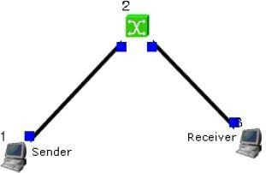
Sender:-
stcp –p 2000 –l 1024 1.0.1.2

Receiver:-
rtcp –p 2000 –l 1024

Parameters:-
Drop Packets and Collision Packets.

Step1: Drawing topology
- Select/click the HOST icon on the toolbar and click the left mouse button on the editor, to place a HOST1 on the editor.
Repeat the above procedure and place another host “HOST2” on the editor.

- Select/click the HUB icon on the toolbar and click the left mouse button on the editor, to place HUB1 on the editor.

- Click on the LINK icon on the toolbar and connect HOST1 to HUB1 and HUB1 to HOST2
- Click on the “E” icon on the toolbar to save the current topology
e.g: file1.tpl
(Look for the ******.tpl extension.)

NOTE: Changes cannot / (should not) be done after selecting the “E” icon.

Step2: Configuration

- Double click the left mouse button while cursor is on HOST1 to open the HOST window.

- Select Add button on the HOST window to invoke the command window and provide the following command in the command textbox.
stg –u 1024 100 1.0.1.2

- Click OK button on the command window to exit and once again click on the OK button on the HOST window to exit.

- Double click the left mouse button while cursor is on HOST2 to open the HOST window.
- Select Add button on the HOST window to invoke the command window and provide the following command in the command textbox.
rtg –u –w log1

- Click OK button on the command window to exit.

- Click NODE EDITOR Button on the HOST window and select the MAC tab from the modal window that pops up.

- Select LOG STATISTICS and select checkboxes for Number of Drop Packet and Number of Collisions in the MAC window

- Click OK button on the MAC window to exit and once again click on the OK button on the HOST window to exit.

Note: To set QUEUE size

- Double click the left mouse button while cursor is on HOST2 to open the HOST window.

- Click NODE EDITOR Button on the HOST window and select the FIFO tab from the modal window that pops up.

- Change Queue size (Default 50).

- Click OK button on the FIFO window to exit and once again click on the OK button on the HOST window to exit.

Step3: Simulate
- Click “R” icon on the tool bar
- Select Simulation in the menu bar and click/ select RUN in the dropdown list to execute the simulation.
- venTo start playback select “►” icon located at the bottom right corner of the editor.
- To view results, Open up new TERMINAL window, move to file1.results folder and open collision and drop log files in separate TERMINAL window.
Caution: file1 is the hypothetical name given to this simulation.

(Refer Step 1.4)

Changing

Configurations Change 1
- Open the above file,
- Do not change the topology or any other configuration,
- Select E icon on the toolbar
- Reduce the bandwidth at link2 by double clicking the left mouse button while cursor is on link2 .(Change bandwidth on both tabs Uplink/Downlink)
- Repeat Step3 (Simulate)

Change 2
- Open the above file,
- Remove HUB and replace it with SWITCH.
- Do not change anything in the configuration Repeat Step3(Simulate)

Experiment .No:2

Simulate to Find the Number of Packets Dropped by TCP/UDP

AIM:
Simulate a four-node point-to-point network and connect the link as follows: Apply a TCP agent between n0 to n3 and apply a UDP agent between n1 and n3. Apply relevant applications over TCP and UDP agents changing the parameters and determine the number of packets sent by two agents.

Topology:-
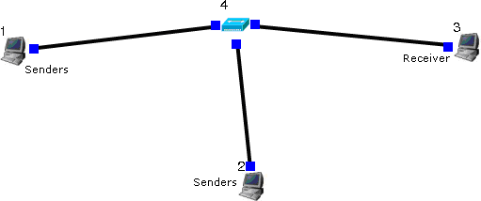
Sender:-
stcp –p 3000 –l 1024 1.0.1.3
stg –u 1024 1.0.1.3

Receiver:-
rtcp –p 3000 –l 1024
rtg –u 3000

Parameters:-
Throughput of incoming and outgoing Packets

Step1: Drawing topology

- Select/click the HOST icon on the toolbar and click the left mouse button on the editor, to place a host on the editor.
Repeat the above procedure and place two other hosts “HOST2” and “HOST3” on the editor.
- Select/click the HUB (or SWITCH) icon on the toolbar and click the left mouse button on the editor, to place a HUB (or SWITCH) on the editor.
- Click on the LINK icon on the toolbar and connect HOST1 to HUB, HOST2 to HUB and HUB to HOST3
- Click on the “E” icon on the toolbar to save the current topology e.g: file2.tpl (Look for the ******.tpl extension.)
NOTE: Changes cannot / (should not) be done after selecting the “E” icon.
Step2: Configuration

- Double click the left mouse button while cursor is on HOST1 to open the HOST window.
- Select Add button on the HOST window to invoke the command window and provide the following command in the command textbox.
stcp –p 21 –l 1024 1.0.1.3
- Click OK button on the command window to exit
- Click NODE EDITOR Button on the HOST window and select the MAC tab from the modal window that pops up.
- Select LOG STATISTICS and select checkbox for output throughput in the MAC window
- Click OK button on the MAC window to exit and once again click on the OK button on the HOST window to exit.
- Double click the left mouse button while cursor is on HOST2 to open the HOST window.
- Select Add button on the HOST window to invoke the command window and provide the following command in the command textbox.
stg –u 1024 100 1.0.1.3
- Click OK button on the command window to exit
- Click NODE EDITOR Button on the HOST window and select the MAC tab from the modal window that pops up.
- Select LOG STATISTICS and select checkbox for output throughput in the MAC window
- Click OK button on the MAC window to exit and once again click on the OK button.on the HOST window to exit.
- Double click the left mouse button while cursor is on HOST3 to open the HOST window.

- Select Add button on the HOST window to invoke the command window and provide the following command in the command textbox.
rtcp –p 21 –l 1024
- Click OK button on the command window to exit.
- Also add the following command on HOST3
rtg –u –w log1
- Click NODE EDITOR Button on the HOST window and select the MAC tab from the modal window that pops up.
- Select LOG STATISTICS and select checkbox for input and output throughput in the MAC window
- Click OK button on the MAC window to exit and once again click on the OK button on the HOST window to exit.
Step3: Simulate

- Click “R” icon on the tool bar
- Select Simulation in the menu bar and click/ select RUN in the dropdown list to execute the simulation.
- To start playback select “►” icon located at the bottom right corner of the editor.
- To view results, Open up new TERMINAL window, move to file2.results folder and open input and output throughput log files in separate TERMINAL window.
Caution: file2 is the hypothetical name given to this simulation.
(Refer Step 1.4)

Experiment No :3
Simulate to Find the Number of Packets Dropped due to Congestion

AIM:
Simulate the transmission of ping messages over a network topology consisting of 6 nodes and find the number of packets dropped due to congestion.

Topology:-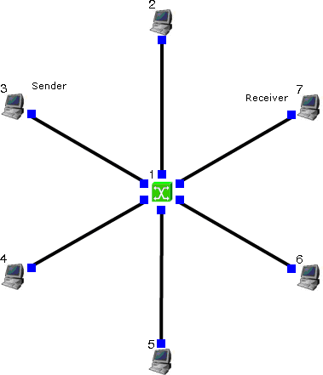
Sender:-
stcp –p 2000 –l 1024 1.0.1.4

Receiver:-
rtcp –p 2000 –l 1024

Command Console:-
Goto tools-> simulation time and change Simulation time to 100. During run mode, double click host 2 and then click command console. And execute the following command.
ping 1.0.1.4 Parameters:-
Drop Packets and Collision Packets.
Step1: Drawing topology
- Select/click the SUBNET icon on the toolbar and click the left mouse button on the editor, to place a SUBNET on the editor.
- A pop up window appears requesting the number of nodes and radius for the subnet Set number of nodes=6;
Set radius of subnet >150
- Click on the “E” icon on the toolbar to save the current topology e.g: file4.tpl (Look for the ******.tpl extension.)
NOTE: Changes cannot / (should not) be done after selecting

Step2: Configuration
- Double click the left mouse button while cursor is on a HOST to open the HOST window.
- Click NODE EDITOR Button on the HOST window and select the INTERFACE tab (1st tab) from the modal window that pops up.
- Determine the IP address of the selected host.
- Click OK button on the INTERFACE window to exit and once again click on the OK button on the HOST window to exit.
- Repeat the above step for 2 other HOSTS
- Also click NODE EDITOR Button on the HOST window and select the MAC tab from the modal window that pops up.
- Select LOG STATISTICS and select checkbox for drop and collision log statistics in the MAC window
- Click OK button on the MAC window to exit and once again click on the OK button on the HOST window to exit.
- Repeat steps 6 to 9 for the other hosts selected at step 5.
- Select G_Setting from the menu bar and select Simulation from the drop down list Set simulation time>600sec

Step3: Simulate
- Click “R” icon on the tool bar
- Select Simulation in the menu bar and click/ select RUN in the dropdown list to execute the simulation.
- During simulation, open a new terminal window.
- Type ping IP address of a host in the subnet at the command prompt.
- To view results, Open up new TERMINAL window, move to file4.results folder and open drop and collision log files in separate TERMINAL window.
Caution: File 4 is the hypothetical name given to this simulation.
(Refer Step 1.3)

Experiment.No:4

Simulate to Compare Data Rate & Throughput

AIM:
Simulate an Ethernet LAN using N nodes (6-10), change error rate and data rate and compare throughput.

Topology:-
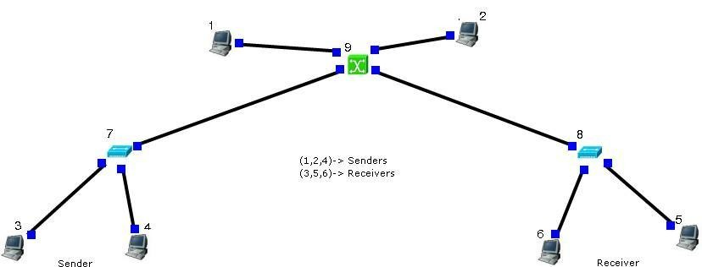

Sender:-
stcp –p 2000 –l 1024 1.0.1.4

Receiver:-
rtcp –p 2000 –l 1024
Double click on receiver link and change BER to 0.000001, Run Again. Parameters:-
Throughput of outgoing Packets

Step1: Drawing topology
- Select/click the HOST icon on the toolbar and click the left mouse button on the editor, to place HOST1 on the editor.
Repeat the above procedure and place 5 other hosts “HOST2”, “HOST3”, “HOST4”, “HOST5”, and “HOST6”on the editor.
- Select/click the HUB icon on the toolbar and click the left mouse button on the editor, to place HUB1 on the editor.
Repeat the above procedure and place another host “HUB2” on the editor
- Click on the LINK icon on the toolbar and connect HOST1, HOST2 and HOST3 toHUB1, HOST4, HOST5 and HOST6 to HUB2.
- Select/click the SWITCH icon on the toolbar and click the left mouse button on the editor, to place SWITCH1 on the editor.
- Click on the LINK icon on the toolbar and connect HUB1 to SWITCH1 and HUB2 to SWITCH1.
- Click on the “E” icon on the toolbar to save the current topology e.g: file5.tpl (Look for the ******.tpl extension.)
NOTE: Changes cannot / (should not) be done after selecting the “E” icon.

Step2: Configuration
- Double click the left mouse button while cursor is on HOST1 to open the HOST window.
- Select Add button on the HOST window to invoke the command window and provide the following command in the command textbox.
stcp –p 21 –l 1024 1.0.1.4
- Click OK button on the command window to exit and once again click on the OK button on the HOST window to exit.
- Repeat this step at HOST 2 and HOST3, but use different commands
stcp –p 21 –l 1024 1.0.1.5 at HOST2
stcp –p 21 –l 1024 1.0.1.6 at HOST3
- Double click the left mouse button while cursor is on HOST4 to open the HOST window.
- Select Add button on the HOST window to invoke the command window and provide the following command in the command textbox.
rtcp –p 21 –l 1024
- Click OK button on the command window to exit.
- Click NODE EDITOR Button on the HOST window and select the MAC tab from the modal window that pops up.
- Select LOG STATISTICS and select checkbox for output throughput in the MAC window
- Click OK button on the MAC window to exit and once again click on the OK button on the HOST window to exit.
- Repeat this step at HOST 5 and HOST6, but use different commands
rtcp –p 21 –l 1024 at HOST5 rtcp –p 21 –l 1024 at HOST6
- Double click the left mouse button while cursor is on HOST5 to open the HOST window.
- Click NODE EDITOR Button on the HOST5 window and select the PHYSICAL tab from the modal window that pops up.
- Change Bit Error Rate
- Click OK button on the PHYSICAL window to exit and once again click on the OK button to return to the HOST window

- Click NODE EDITOR Button on the HOST window and select the MAC tab from the modal window that pops up.
- Select LOG STATISTICS and select checkbox for output throughput in the MAC window
- Click OK button on the MAC window to exit and once again click on the OK button on the HOST window to exit.
- Repeat this step HOST6, Change Bandwidth this time while undoing the change in Bit Error Rate, also select the output throughput at HOST6.

Step3: Simulate
- Click “R” icon on the tool bar
- Select Simulation in the menu bar and click/ select RUN in the dropdown list to execute the simulation.
- To start playback select “►” icon located at the bottom right
- To view results, Open up new TERMINAL window, move to file5.results folder and open output throughput log files in separate TERMINAL window.
Caution: File5 is the hypothetical name we gave to this simulation
(Refer Step 1.7)
Experiment No:5

Simulate to Plot Congestion for Different

Source / Destination
Aim :

Simulate an Ethernet LAN using N nodes and set multiple traffic nodes and plot congestion window for different source/destination.

Topology:-


Sender:-
stcp –p 2000 –l 1024 1.0.1.4

Receiver:-
rtcp –p 2000 –l 1024

Parameters:-
Receiver side Collision Packets and Drop Packets

Step1: Drawing topology
- Select/click the HOST icon on the toolbar and click the left mouse button on the editor, to place HOST1 on the editor.
Repeat the above procedure and place 3 other hosts “HOST2”, “HOST3”, “HOST4”, “HOST5”, and “HOST6”on the editor.
- Select/click the HUB icon on the toolbar and click the left mouse button on the editor, to place HUB1 on the editor.
Repeat the above procedure and place another host “HUB2” on the editor
- Click on the LINK icon on the toolbar and connect HOST1, HOST2 and HOST3 to HUB1, HOST4, HOST5 and HOST6 to HUB2.
- Select/click the SWITCH icon on the toolbar and click the left mouse button on the editor, to place SWITCH1 the editor.
- Click on the LINK icon on the toolbar and connect HUB1 to SWITCH1 and HUB2 to SWITCH1.
- Click on the “E” icon on the toolbar to save the current topology e.g: file7.tpl (Look for the ******.tpl extension.)
NOTE: Changes cannot / (should not) be done after selecting the “E” icon.

Step2: Configuration
- Double click the left mouse button while cursor is on HOST1 to open the HOST window.
- Select Add button on the HOST window to invoke the command window and provide the following command in the command textbox.
stcp –p 21 –l 1024 1.0.1.4
- Click OK button on the command window to exit and once again click on the OK button on the HOST window to exit.
- Repeat this step at HOST 2 and HOST3, but use different commands
stcp –p 23 –l 1024 1.0.1.5 at HOST2
stcp –p 25 –l 1024 1.0.1.6 at HOST3
- Double click the left mouse button while cursor is on HOST4 to open the HOST window.
- Select Add button on the HOST window to invoke the command window and provide the following command in the command textbox.
rtcp –p 21 –l 1024
- Click OK button on the command window to exit.
- Click NODE EDITOR Button on the HOST window and select the MAC tab from the modal window that pops up.
- Select LOG STATISTICS and select checkbox for Number of drop and collisions packets in the MAC window
- Click OK button on the MAC window to exit and once again click on the OK button on the HOST window to exit.
- Repeat this step at HOST 5 and HOST6, but use different commands
rtcp –p 23 –l 1024 at HOST5 rtcp –p 25 –l 1024 at HOST6
- Double click the left mouse button while cursor is on HOST5 to open the HOST window.
- Click NODE EDITOR Button on the HOST5 window and select the MAC tab from the modal window that pops up.
- Select LOG STATISTICS and select checkbox for Number of drop and collisions packets in the MAC window
- Click OK button on the MAC window to exit and once again click on the OK button on the HOST window to exit.
- Also select the drop and collisions at HOST6.
Step3: Simulate
- Click “R” icon on the tool bar
- Select Simulation in the menu bar and click/ select RUN in the dropdown list to execute the simulation.
- To start playback select “►” icon located at the bottom right corner of the editor.
- To plot congestion window select Tools in the menu bar and select PLOT GRAPH in the drop down list.
- In the Graph window, select File->OPEN, move to file7.results folder and the drop and collision log file.
- To open another Graph window, Select File->New tab on the drop down list to open up to a maximum of 6 windows
- To view results, Open up new TERMINAL window, move to file7.results folder and open input and output throughput log files in separate TERMINAL window.
Caution: file7 is the hypothetical name given to this simulation.

Experiment .No:6
Simulate to Determine the Performance with respect to Transmission of Packets

AIM:
Simulate simple ESS and with transmitting nodes in wireless LAN by simulation and determine the performance with respect to transmission of packets.

Topology:-
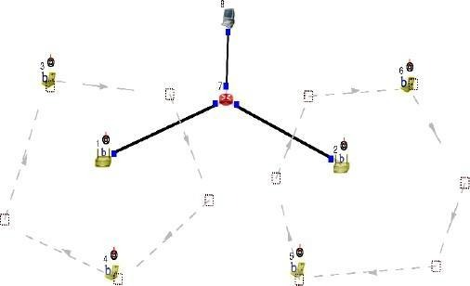
Click on “access point”. Goto wireless interface and tick on “show transmission range and then click OK.

Double click on Router -> Node Editor and then Left stack -> throughput of Incoming packets Right stack -> throughput of Outgoing packets

Select mobile hosts and access points then click on.
Tools -> WLAN mobile nodes-> WLAN Generate infrastructure.
Subnet ID: Port number of router (2) Gateway ID: IP address of router

Mobile Host 1
ttcp –t –u –s –p 3000 1.0.1.1

Mobile Host 1
ttcp –t –u –s –p 3001 1.0.1.1
Host(Receiver)
ttcp –r –u –s –p 3000 ttcp –r –u –s –p 3001

Run and then play to plot the graph.

Step1: Drawing topology
- Select/click the HOST icon on the toolbar and click the left mouse button on the editor, to place HOST1 on the editor.
- Select/click the ROUTER icon on the toolbar and click the left mouse button on the editor, to place ROUTER1 on the editor.
- Select/click the WIRELESS ACCESS POINT(802.11b) icon on the toolbar and click the left mouse button on the editor, to place ACCESS POINT 1 on the editor.
Repeat this procedure and place ACCESS POINT 2 on the editor.
- Select/click the MOBILE NODE (infrastructure mode) icon on the toolbar and click the left mouse button on the editor, to place MOBILE NODE 1 on the editor.
Repeat this procedure and place MOBILE NODE 2, MOBILE NODE3 and MOBILE
NODE 4 on the editor.
- Click on the LINK icon on the toolbar and connect ACCESS POINT1 to ROUTER1 and ACCESS POINT2 to ROUTER1
- Click on the “Create a moving path” icon on the toolbar and draw moving path across MOBILE NODE 1 and 2, Repeat for MOBILE NODE 3and 4 (Accept the default speed value 10 and close the window, Click the right mouse button to terminate the path).

To create Subnet
- Select wireless subnet icon in the toolbar now select MOBILE NODE1, MOBILE NODE2 and ACCESS POINT1 by clicking on left mouse button, and clicking right mouse button will create a subnet.
- Repeat the above step for MOBILE NODE3, MOBILE NODE4 and ACCESS POINT2.
- Click on the “E” icon on the toolbar to save the current topology e.g: file8.tpl (Look for the ******.tpl extension.)
NOTE: Changes cannot / (should not) be done after selecting the “E” icon.

Step2: Configuration
- Double click the left mouse button while cursor is on HOST1 to open the HOST window.
- Select Add button on the HOST window to invoke the command window and provide the following command in the command textbox.
ttcp –r –u –s –p 8001
- Click OK button on the command window to exit
- Repeat this step and add the following commands at HOST1
ttcp –r –u –s –p 8002
ttcp –r –u –s –p 8003
ttcp –r –u –s –p 8004

- Click NODE EDITOR Button on the HOST1 window and select the MAC tab from the modal window that pops up.
- Select LOG STATISTICS and select checkbox for Input throughput in the MAC window
- Click OK button on the MAC window to exit and once again click on the OK button on the HOST window to exit.
- Double click the left mouse button while cursor is on MOBILE NODE 1 to open the MOBILE NODE window.
- Select Application tab and select Add button to invoke the command window and provide the following command in the command textbox.
ttcp –t –u –s –p 80011.0.2.2 (host’s ip address)
- Click NODE EDITOR Button on the MOBILE NODE1 window and select the MAC tab from the nodal window that pops up.
- Select LOG STATISTICS and select checkbox for Output throughput in the MAC window
- Click OK button on the MAC window to exit and once again click on the OK button on the MOBILE NODE1 window to exit.
- Repeat the above steps (step 8 to step12) for the MOBILE NODE2,3 and 4 and add the following commands at
MOBILE NODE2:- ttcp –t –u –s –p 8002 1.0.2.2 MOBILE NODE3:- ttcp –t –u –s –p 8003 1.0.2.2 MOBILE NODE4:- ttcp –t –u –s –p 8004 1.0.2.2
- Double click the left mouse button while cursor is on ROTER1 to open the ROUTER window.
- Click NODE EDITOR Button on the ROUTER1 window and you can see three stacks. two stacks for two ACCESS POINTS and another stack for HOST1 which is connected to the ROUTER1.
- Select the MAC tab of ACCESS POINT1 and Select LOG STATISTICS and select checkbox for Input throughput in the MAC window. Click OK button on the MAC window to exit.
- Select the MAC tab of ACCESS POINT2 and Select LOG STATISTICS and select checkbox for Input throughput in the MAC window. Click OK button on the MAC window to exit.
- Select the MAC tab of HOST1 and Select LOG STATISTICS and select checkbox for Output throughput in the MAC window. Click OK button on the MAC window to exit.

Step3: Simulate
- Click “R” icon on the tool bar
- Select Simulation in the menu bar and click/select RUN in the dropdown list to execute the simulation.
- To start playback select “►” icon located at the bottom right corner of the editor.
- MOBILE NODE’s start moving across the paths already drawn.
Caution: File8 is the hypothetical name given to

